Commercial offer

1 | Business name | «Navoi Mining and Metallurgical Combinat» State Company (NMMC)
2 | Brief information about the company | NMMC is a commercial organization in the form of a state enterprise.  September 1, 1958, the date of establishment of NMMC
3 | Company logo |  | NMMC
4 | Address | Republic of Uzbekistan, Navoi region, Navoi city, Address: Navoi 27
5 | FULL NAME. head of the enterprise | Sanakulov Kuvandik Sanakulovich
6 | Phone | 0 (436) 227-71-64
7 | Fax | + (99879) 22-77-566
8 | E-mail address | info@ngmk.uz
9 | Site | www.ngmk.uz
10 | Manufactured products | Lathe universal lathe HT-250
11 | Quality parameters of products | High quality
12 | Volume of production | -
13 | Certificate of quality | SGS
14 | Packaging | Non-returnable wooden packaging
15 | Price (in USD / unit) | Private negotiation
16 | Delivery conditions | FCA of Navoi, according to Incoterms-2010
17 | Product photos | 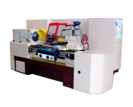

Commercial offer

1 | Business name | «Navoi Mining and Metallurgical Combinat» State Company (NMMC)
2 | Brief information about the company | NMMC is a commercial organization in the form of a state enterprise.  September 1, 1958, the date of establishment of NMMC
3 | Company logo |  | NMMC
4 | Address | Republic of Uzbekistan, Navoi region, Navoi city, Address: Navoi 27
5 | FULL NAME. head of the enterprise | Sanakulov Kuvandik Sanakulovich
6 | Phone | 0 (436) 227-71-64
7 | Fax | + (99879) 22-77-566
8 | E-mail address | info@ngmk.uz
9 | Site | www.ngmk.uz
10 | Manufactured products | The grinding machine grinding 3Н340
11 | Quality parameters of products | High quality
12 | Volume of production | -
13 | Certificate of quality | SGS
14 | Packaging | Non-returnable wooden packaging
15 | Price (in USD / unit) | Private negotiation
16 | Delivery conditions | FCA of Navoi, according to Incoterms-2010
17 | Product photos | 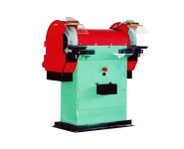

Commercial offer

1 | Business name | «Navoi Mining and Metallurgical Combinat» State Company (NMMC)
2 | Brief information about the company | NMMC is a commercial organization in the form of a state enterprise.  September 1, 1958, the date of establishment of NMMC
3 | Company logo |  | NMMC
4 | Address | Republic of Uzbekistan, Navoi region, Navoi city, Address: Navoi 27
5 | FULL NAME. head of the enterprise | Sanakulov Kuvandik Sanakulovich
6 | Phone | 0 (436) 227-71-64
7 | Fax | + (99879) 22-77-566
8 | E-mail address | info@ngmk.uz
9 | Site | www.ngmk.uz
10 | Manufactured products | The machine tool desktop-drilling 21Н16
11 | Quality parameters of products | High quality
12 | Volume of production | -
13 | Certificate of quality | SGS
14 | Packaging | Non-returnable wooden packaging
15 | Price (in USD / unit) | Private negotiation
16 | Delivery conditions | FCA of Navoi, according to Incoterms-2010
17 | Product photos | 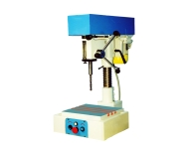

Commercial offer

1 | Business name | «Navoi Mining and Metallurgical Combinat» State Company (NMMC)
2 | Brief information about the company | NMMC is a commercial organization in the form of a state enterprise.  September 1, 1958, the date of establishment of NMMC
3 | Company logo |  | NMMC
4 | Address | Republic of Uzbekistan, Navoi region, Navoi city, Address: Navoi 27
5 | FULL NAME. head of the enterprise | Sanakulov Kuvandik Sanakulovich
6 | Phone | 0 (436) 227-71-64
7 | Fax | + (99879) 22-77-566
8 | E-mail address | info@ngmk.uz
9 | Site | www.ngmk.uz
10 | Manufactured products | Milling machine vertical boring NF-630M
11 | Quality parameters of products | High quality
12 | Volume of production | -
13 | Certificate of quality | SGS
14 | Packaging | Non-returnable wooden packaging
15 | Price (in USD / unit) | Private negotiation
16 | Delivery conditions | FCA of Navoi, according to Incoterms-2010
17 | Product photos | 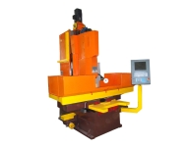

Commercial offer

1 | Business name | «Navoi Mining and Metallurgical Combinat» State Company (NMMC)
2 | Brief information about the company | NMMC is a commercial organization in the form of a state enterprise.  September 1, 1958, the date of establishment of NMMC
3 | Company logo |  | NMMC
4 | Address | Republic of Uzbekistan, Navoi region, Navoi city, Address: Navoi 27
5 | FULL NAME. head of the enterprise | Sanakulov Kuvandik Sanakulovich
6 | Phone | 0 (436) 227-71-64
7 | Fax | + (99879) 22-77-566
8 | E-mail address | info@ngmk.uz
9 | Site | www.ngmk.uz
10 | Manufactured products | Screw-cutting lathe 1M63N (3-meter bed)
11 | Quality parameters of products | High quality
12 | Volume of production | -
13 | Certificate of quality | SGS
14 | Packaging | Non-returnable wooden packaging
15 | Price (in USD / unit) | Private negotiation
16 | Delivery conditions | FCA of Navoi, according to Incoterms-2010
17 | Product photos | 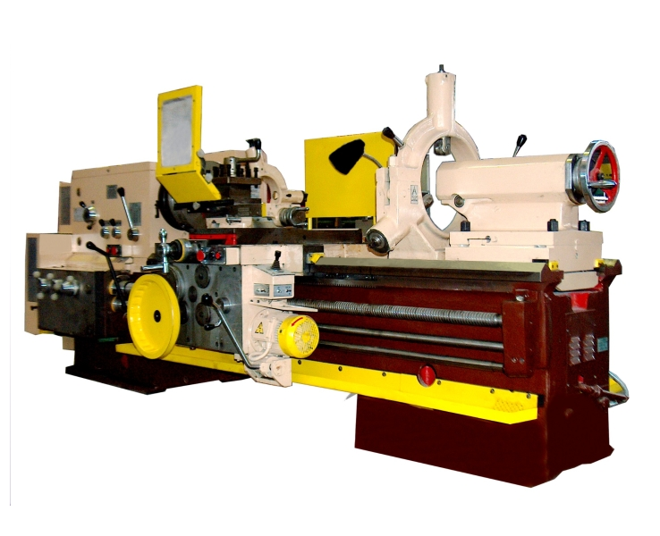

Commercial offer

1 | Business name | «Navoi Mining and Metallurgical Combinat» State Company (NMMC)
2 | Brief information about the company | NMMC is a commercial organization in the form of a state enterprise.  September 1, 1958, the date of establishment of NMMC
3 | Company logo |  | NMMC
4 | Address | Republic of Uzbekistan, Navoi region, Navoi city, Address: Navoi 27
5 | FULL NAME. head of the enterprise | Sanakulov Kuvandik Sanakulovich
6 | Phone | 0 (436) 227-71-64
7 | Fax | + (99879) 22-77-566
8 | E-mail address | info@ngmk.uz
9 | Site | www.ngmk.uz
10 | Manufactured products | Ammonium perrhenate (NH4ReO4), grade AP-0, corresponding to GOST 31411-2009
11 | Quality parameters of products | High quality
12 | Volume of production | -
13 | Certificate of quality | -
14 | Packaging | Wooden Boxes
15 | Price (in USD / unit) | The upper quotation Rhenium basic APR min 69.2%, as indicated in argusmedia.com
16 | Delivery conditions | FCA of Navoi, according to Incoterms-2010
17 | Product photos | 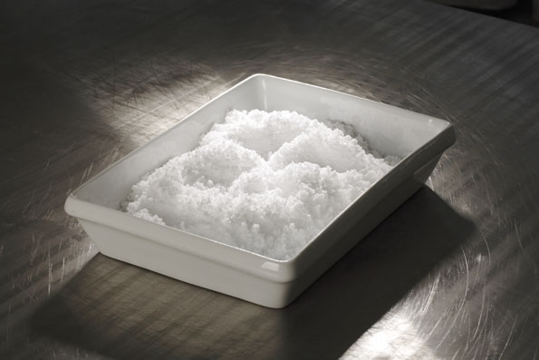

Commercial offer

1 | Business name | «Navoi Mining and Metallurgical Combinat» State Company (NMMC)
2 | Brief information about the company | NMMC is a commercial organization in the form of a state enterprise.  September 1, 1958, the date of establishment of NMMC
3 | Company logo |  | NMMC
4 | Address | Republic of Uzbekistan, Navoi region, Navoi city, Address: Navoi 27
5 | FULL NAME. head of the enterprise | Sanakulov Kuvandik Sanakulovich
6 | Phone | 0 (436) 227-71-64
7 | Fax | + (99879) 22-77-566
8 | E-mail address | info@ngmk.uz
9 | Site | info@ngmk.uz
10 | Manufactured products | Lime air quicklime calcium lump with a content (CaO + MgO) of at least 70%.
11 | Quality parameters of products | High quality
12 | Volume of production | -
13 | Certificate of quality | -
14 | Packaging | In bulk, it is transported by open rail and road transport
15 | Price (in USD / unit) | Private negotiation
16 | Delivery conditions | FCA of Navoi, according to Incoterms-2010
17 | Product photos | 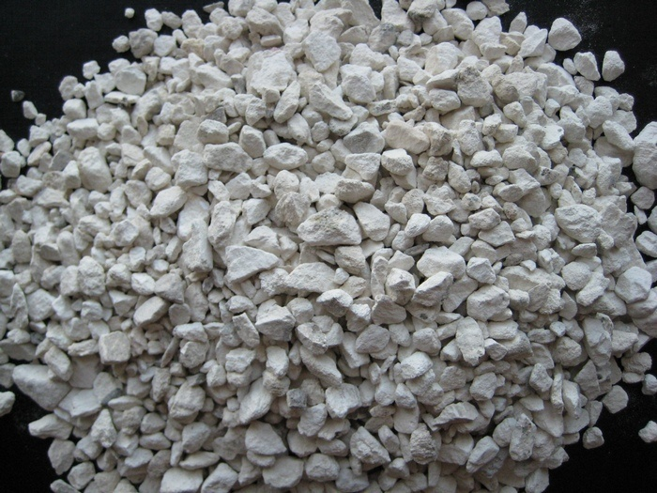

Commercial offer

1 | Business name | «Navoi Mining and Metallurgical Combinat» State Company (NMMC)
2 | Brief information about the company | NMMC is a commercial organization in the form of a state enterprise.  September 1, 1958, the date of establishment of NMMC
3 | Company logo |  | NMMC
4 | Address | Republic of Uzbekistan, Navoi region, Navoi city, Address: Navoi 27
5 | FULL NAME. head of the enterprise | Sanakulov Kuvandik Sanakulovich
6 | Phone | 0 (436) 227-71-64
7 | Fax | + (99879) 22-77-566
8 | E-mail address | info@ngmk.uz
9 | Site | info@ngmk.uz
10 | Manufactured products | Мраморная плитка
11 | Quality parameters of products | High quality
12 | Volume of production | -
13 | Certificate of quality | -
14 | Packaging | -
15 | Price (in USD / unit) | Private negotiation
16 | Delivery conditions | FCA of Navoi, according to Incoterms-2010
17 | Product photos | 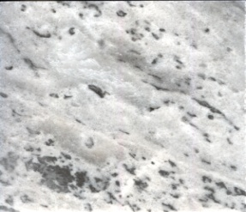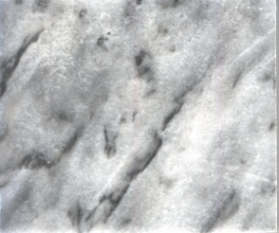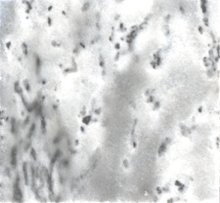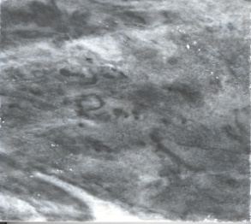

Commercial offer

1 | Business name | «Navoi Mining and Metallurgical Combinat» State Company (NMMC)
2 | Brief information about the company | NMMC is a commercial organization in the form of a state enterprise.  September 1, 1958, the date of establishment of NMMC
3 | Company logo |  | NMMC
4 | Address | Republic of Uzbekistan, Navoi region, Navoi city, Address: Navoi 27
5 | FULL NAME. head of the enterprise | Sanakulov Kuvandik Sanakulovich
6 | Phone | 0 (436) 227-71-64
7 | Fax | + (99879) 22-77-566
8 | E-mail address | info@ngmk.uz
9 | Site | www.ngmk.uz
10 | Manufactured products | Chicken eggs.
11 | Quality parameters of products | High quality
12 | Volume of production | -
13 | Certificate of quality | -
14 | Packaging | -
15 | Price (in USD / unit) | Private negotiation
16 | Delivery conditions | FCA of Navoi, according to Incoterms-2010
17 | Product photos

