1 | Facility’s name | LLC «Mubarek Gas Processing Plant»
2 | Brief information about the company (year of establishment, staff, etc.) | The year of launch is December 31, 1971.
3 | Companylogo
4 | Address | Republic of Uzbekistan, Kashkadarya region, Mubarek district, Sanoat square
5 | FULL NAME. head of an enterprise | ShamsievShermatZhurakulovich
6 | Telephone | +998 98 775 51 96 0 (375) 672 50 07
7 | Fax | 0 (375) 672 50 11
8 | E-mail | mgpz@mgpz.uz, muborakgpz@exat.uz
9 | Site | http://mgpz.uz
10 | Manufactured products | Granularsulfur, lumpsulfur
11 | Quality parameters of products | Gost 127.1-93; The mass fraction of sulfur is not less than -99.90%.
12 | Volume of production | Granular sulfur 80.0 thousand tons and lump sulfur 280.0 thousand tons. The whole volume of 2018 has contracted.
13 | Certificate of quality | 07.12.2017 UZ.SMT.01.318.2079131 until 07.12.2020
14 | Package | Big-Bag or Liner-Bag
15 | Price (USD / unit) | Lump sulfur $ 10.0); Granular sulfur $ 22.0
16 | Delivery conditions | FCA (Incoterms - 2010) St. “Sulfur Plant” UTY
17 | Product photos | 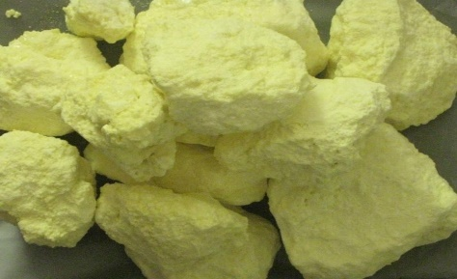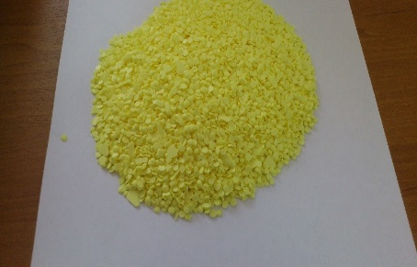

Commercial offer

1 | Facility’s name | LLC «Ferghana Oil Refinery Plant»
2 | Brief information about the company (year of establishment, staff, etc.) | The year of launch is January 27, 1959.
3 | Companylogo
4 | Address | Republic of Uzbekistan, Ferghana region, Fergana city, Sanoat 240
5 | FULL NAME. head of an enterprise | AbdukarimovRustambekSobirjonovich
6 | Telephone | +99873 229 45 19
7 | Fax | +99873 229 45 76
8 | E-mail | refinery@fnpz.uz
9 | Site | http://fnpz.uz
10 | Manufactured products | Gach-II fraction, industrial oil I-12A, industrial oil I-20A, industrial oil I-40A, industrial oil I-50A, base oil SN-150, engine oil M20A, oil SN-100, petrolatum PS-55
11 | Quality parameters of products | Extra Class
12 | Volume of production | 5.5 million tons of hydrocarbons per year
13 | Certificate of quality | The quality management system-QMS, according to the requirements of the ISO 9001: 2008 standard, QMS is certified in 2006, twice recertified in 2009 and 2012
14 | Package | Railway tank (flexitank)
15 | Price (USD / unit) | From 455 to 720 US dollars per ton
16 | Delivery conditions | FCA (Incoterms - 2010) St. “Akhunbabaev” UTY, Ferghana
17 | Product photos

1 | Facility’s name | LLC «Shurtan Gas Chemical Complex»
2 | Brief information about the company (year of establishment, staff, etc.) | The year of launch is 2001.
3 | Companylogo
4 | Address | Republic of Uzbekistan, Kashkadarya region, Shurtan fortress
5 | FULL NAME. head of an enterprise | Асланов ШухратЧориевич
6 | Telephone | +99875 552 42 30, +99875 221 02 27
7 | Fax
8 | E-mail | info@sgcc.uz
9 | Site | https://sgcc.uz
10 | Manufactured products | Polyethylene (grades F-0120, F-0320, B-Y460, P-Y342, P-Y456, I-0760, I-1561)
11 | Quality parameters of products | Extra Class
12 | Volume of production | 125 000 tones
13 | Certificate of quality | Ts 17642168-04: 2013
14 | Package | 25kg polyethylene bags
15 | Price (USD / unit) | 1 110 - 1 400 US dollars/per tone
16 | Delivery conditions | FCA (Incoterms - 2010) St. “Kengsay” UTY
17 | Product photos | 