COMMERCIAL PROPOSAL
Company Name | “Samarkand Automobile Factory” LLC
Brief information about the company | Our organization was established in 1999 in Samarkand city. In Tashkent city there is a representative office. To date, the company employs 983 people.
Company’s logo
Address | Samarkand city, Bukhoriy street, 5
CEO Name | Yuldashev Ulmas
Phone number | (+9971) 140 64 64, (+99871) 141 87 00, (+99866) 230 87 00
Fax | (+99866) 2223839
E-mail | info@samauto.uz, saminfo@samauto.uz
Web-site | www.samauto.uz
Products Produced | City and suburban buses (M3 categories of class I, II, III), medium and heavy-duty trucks (categories N2 and N3), specialized equipment: ambulance cars, fire trucks, etc.
Products quality parameters | Buses: Length - from 7 to 8 meters, Passenger capacity - from 32 to 56 people;  Trucks: Carrying capacity from 2 to 8 tons
Production volume | 4 000 units per year
Quality certificates | ISO 9001:2015, ISO 14001:2015, OHSAS 18001:2007, ISO 50001:2011
Packaging
Price (USD / unit) | According to the price list (Appendix #1)
Delivery conditions
Product photos | 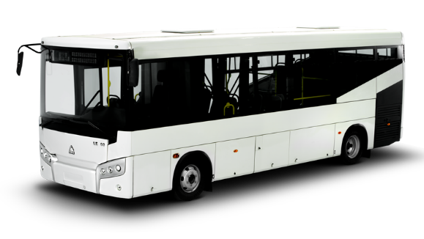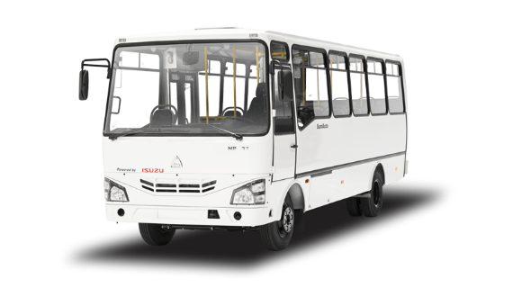  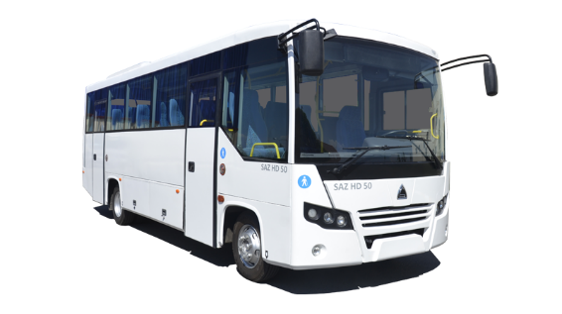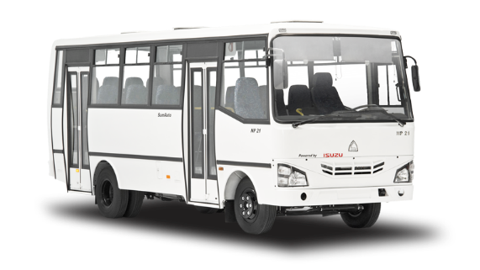  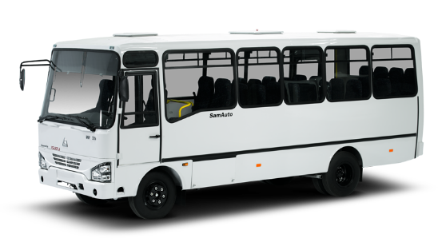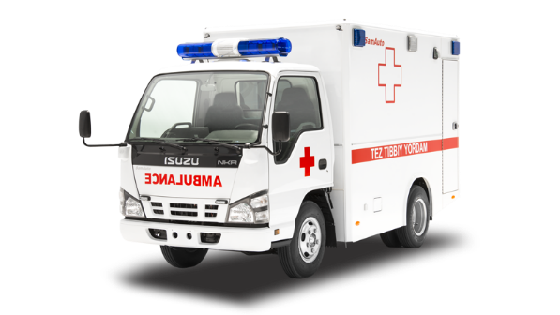  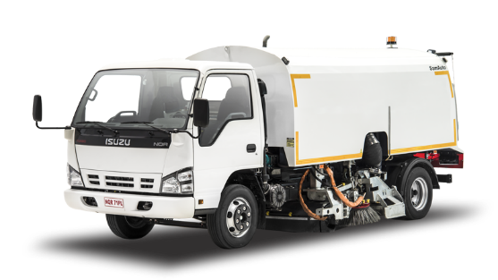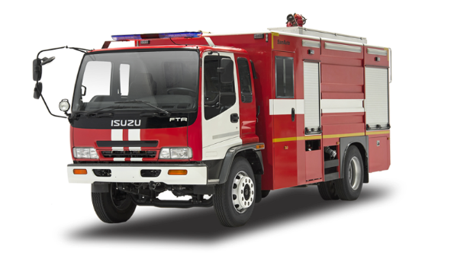  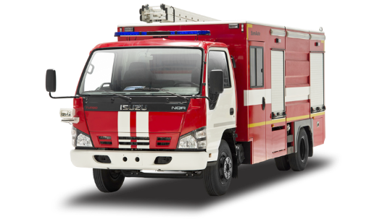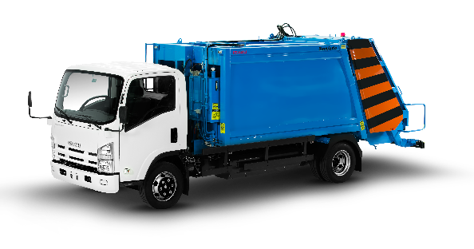  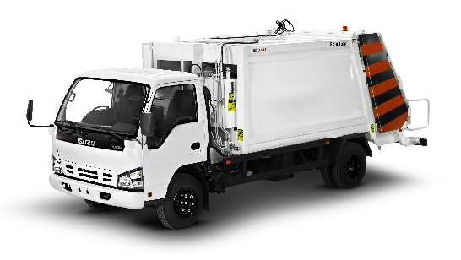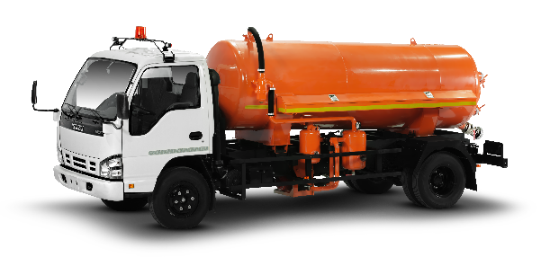  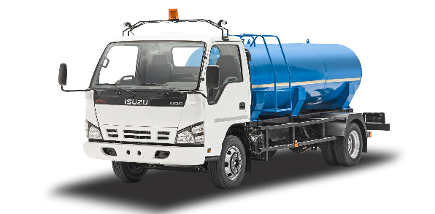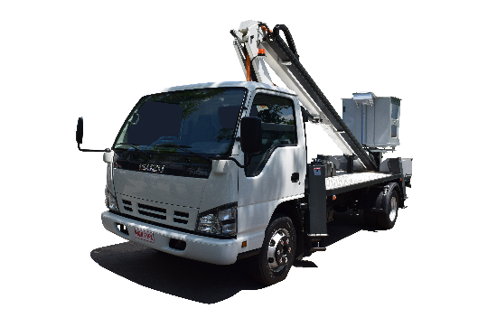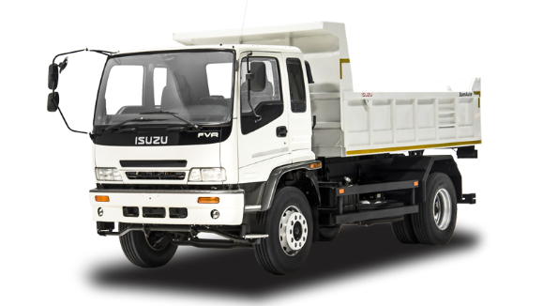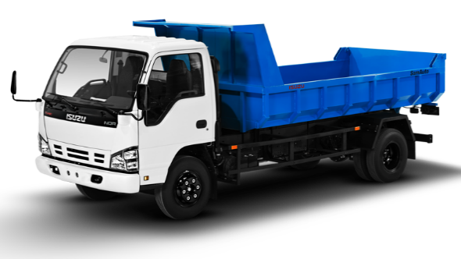  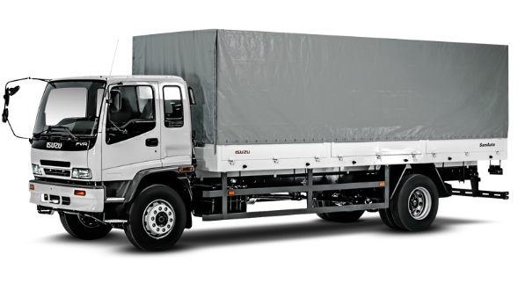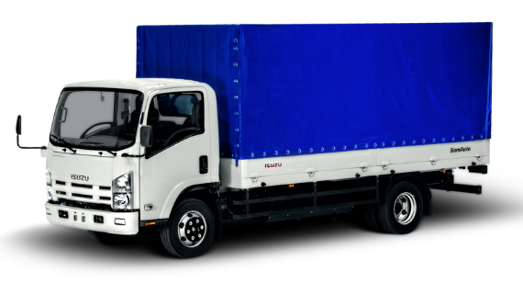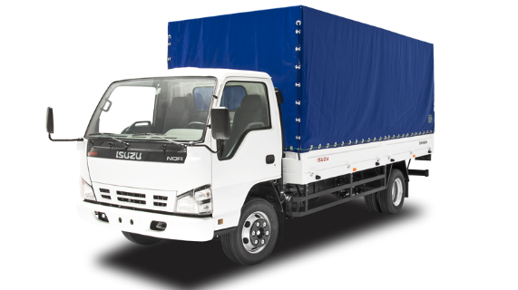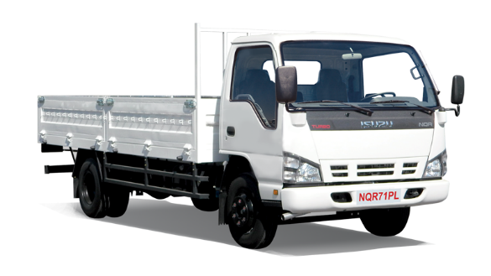  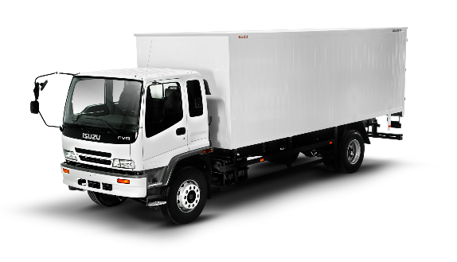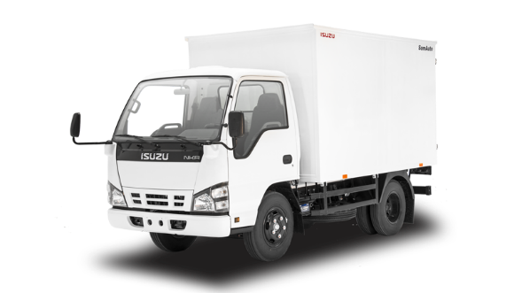  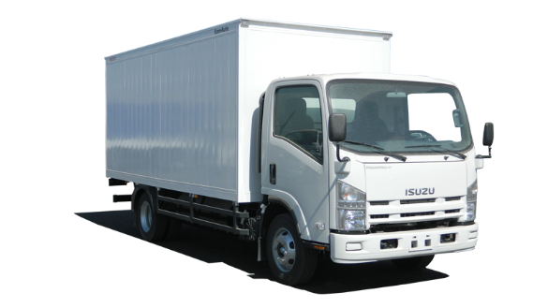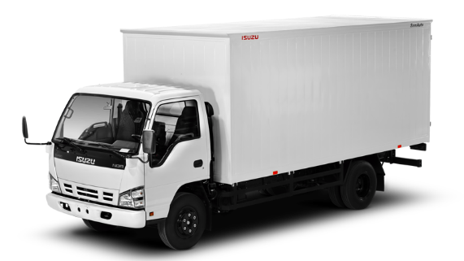  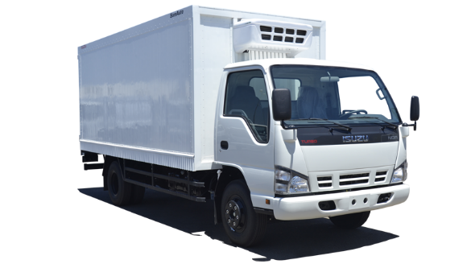

Appendix #1
Price-list of «Samarkand Automobile Factory» LLC
№ | Product name | Model | Performance specification | * Unit Price  EXW-Samarkand, USD | Photo
1 | City Low Entry Bus | SAZ LE 60 | Overall dimensions (L/W/H) – 8065/2470/2750 mm  Passengers capacity – 56 persons  Passenger seats – 25 persons  Gross vehicle weight (GVW) – 10 200 kg  Engine model – ISUZU 4HK1-TCC, diesel, Euro 4-5  Maximum power – 185 hp/130 kW(2600 rpm)  Vehicle control type: Left hand drive | 75 000 | 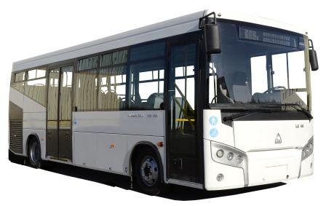
2 | Intercity bus | SAZ HD 50 | Overall dimensions (L/W/H) – 8010/2320/2800 mm  Passengers capacity – 44 persons  Passenger seats – 29 persons  Gross vehicle weight (GVW) – 9 500 kg  Engine model – ISUZU 4HK1-TCN, diesel, Euro 4-5  Maximum power – 140 hp/109 kW(2600 rpm)  Vehicle control type: Left hand drive | 63 000 | 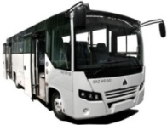
3 | Intercity bus (CNG) | SAZ HC45 | Passengers capacity - 32 persons  Passenger seats – 18 persons  Overall dimensions (L/W/H) – 7100х2250х2880mm  Gross vehicle weight (GVW) – 7 500 kg  Engine model – ISUZU 4HV1 CNG, Euro-4  Maximum power – 130 л.hp/96 kW (3200 rpm)  Ёмкость топливных баков 2 шт – 30/30 м3 =60 м3 | 50 000 | 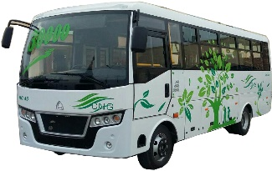
4 | City Bus | SAZ HD 41 | Overall dimensions (L/W/H) – 6920х2240х2880 mm  Passengers capacity – 45 persons  Passenger seats – 17 persons  Engine model – ISUZU 4HG1, diesel, Euro 3  Maximum power – 121 hp/89 kW (3200 rpm)  Vehicle control type: Left hand drive | 37 000 | 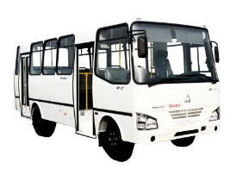
5 | City Bus | SAZ HC 40 | Overall dimensions (L/W/H): 6920 / 2240 / 2880 mm  Passengers capacity – 38 persons  Passenger seats – 16 persons  Engine model – ISUZU 4HF1, diesel, Euro 2  Maximum power – 104 hp/78 kW(3200 rpm)  Vehicle control type: Left hand drive | 31 500 | 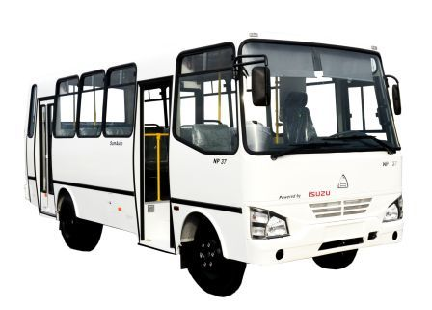
6 | Intercity bus | SAZ NP 26 | Overall dimensions (L/W/H): 6920 / 2240 / 2880 mm  Passengers capacity – 26 persons  - passenger – 24 seats  - crew – 2 seats  Engine model – ISUZU 4HF1, diesel, Euro 2  Maximum power – 104 hp /78 kW(3200 rpm)  Vehicle control type: Left hand drive | 33 000 | 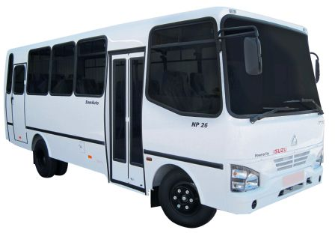
7 | Intercity bus | SAZ NP 21 | Overall dimensions (L/W/H): 6920 / 2240 / 2880 mm  Passengers capacity – 21 persons  - passenger – 20 seats  - crew – 2 seats  Engine model – ISUZU 4HF1, diesel, Euro 2  Maximum power – 104 hp /78 kW(3200 rpm)  Vehicle control type: Left hand drive | 33 000 | 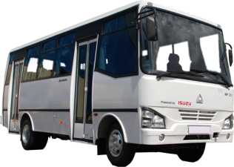
8 | Van | ISUZU  NPR82 (CNG) | Overall dimensions (L/W/H) – 6795 / 2300 / 3000 mm  Payload – 3550 kg  Engine model – ISUZU 4HV1, Euro 4  Maximum power – 131 hp /96 kW(3200 rpm)  Fuel type – compressed natural gas (CNG)  Vehicle control type: Left hand drive | 37 500 | 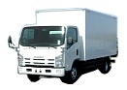
9 | Cargo tent truck | ISUZU  NPR82 (CNG) | Overall dimensions (L/W/H)– 6795 / 2300 / 3000 mm  Payload – 3550 kg  Engine model – ISUZU 4HV1, Euro 4  Maximum power – 131 hp /96 kW(3200 rpm)  Fuel type– compressed natural gas (CNG)  Vehicle control type: Left hand drive | 37 000 | 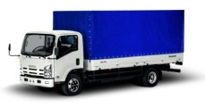
10 | Garbage truck | ISUZU  NPR82 (CNG) | Overall dimensions (L/W/H)– 7300 / 2240 / 2840 mm  Payload – 1140 kg  Body space – 7 mc  Engine model – ISUZU 4HV1, Euro 4  Maximum power – 131 hp /96 kW(3200 rpm)  Fuel type– compressed natural gas (CNG) | 54 000 | 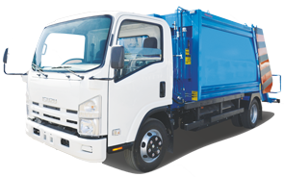
11 | Dump truck | ISUZU  NPR82 (CNG) | Overall dimensions (L/W/H) – 6214 / 2150 / 2454 mm  Payload – 4000 kg  Engine model – ISUZU 4HV1, Euro 4  Maximum power – 121 hp /89 kW(3200 rpm)  Fuel type– compressed natural gas (CNG)  Vehicle control type: Left hand drive | 45 000 | 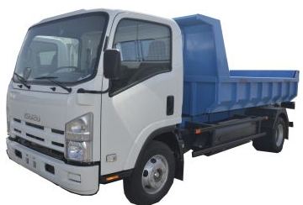
12 | Cesspool cleaner | ISUZU NPR82 (CNG) | Overall dimensions (L/W/H) – 7060 / 1665 / 2560 mm  Tank volume – 4120 l,  Engine model – ISUZU 4HV1, diesel, Euro 4  Maximum power – 130 hp /96 kW(3200 rpm)  Fuel type– compressed natural gas (CNG)  Vehicle control type: Left hand drive | 44 700 | 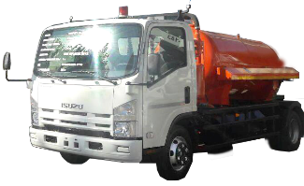
13 | Chassis | ISUZU  NKR 55E | Overall dimensions (L/W/H) – 4610 / 1860 / 2120 mm  Gross vehicle weight – 5 200 kg  Chassis mass – 2 885 kg,  Engine model – ISUZU 4JB1, diesel, Euro 2  Maximum power – 80 hp /59 kW (3600 rpm)  Wheel base – 2 460 mm | 20 000 | 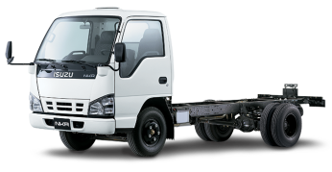
14 | Van | ISUZU  NKR 55E | Overall dimensions (L/W/H) – 4730/ 1975 / 2750 mm  Payload – 2430 kg  Engine model – ISUZU 4JB1, diesel, Euro 2  Maximum power – 59 hp /80 kW(3600 rpm)  Vehicle control type: Left hand drive | 24 000
15 | Isothermal van | ISUZU  NKR 55E | Payload – 2430 kg  Engine model – ISUZU 4JB1, diesel, Euro 2  Overall dimensions (L/W/H) – 4730/ 1975 / 2750 mm  Maximum power – 59 hp /80 kW(3600 rpm)  Vehicle control type: Left hand drive | 27 000
16 | Refrigerated van | ISUZU  NKR 55E | Overall dimensions (L/W/H) – 4730/1975/2750 mm  Payload – 2350 kg, Body space – 14 mc  Cooling temperature – (+5С⁰ ÷ -5С⁰) / (0С⁰ ÷ -18С⁰)  Engine model – – ISUZU 4JB1, diesel, Euro 2  Maximum power – 80 hp /59 kW (3600 rpm)  Wheel base – 2 460 mm | 30 000
17 | Ambulance | ISUZU  NKR 55E | Overall dimensions (L/W/H) – 5110 / 1950 / 2660 mm  Gross vehicle weight – 5 200 kg  Engine model – ISUZU 4JB1, diesel, Euro 2  Maximum power – 80 hp /59 kW (3600 rpm)  Wheel base – 2 460 mm | 57 000
18 | Chassis | ISUZU NMR 77H  (Euro 3) | Overall dimensions (L/W/H)- 4730х1815х2160 mm,  Gross vehicle weight – 5 200 kg  Engine model – ISUZU 4JH1-TC, diesel, Euro 3  Maximum power – 96 hp /106 kW (3200 rpm)  Breaking system – drum type with ABS | 22 500
19 | Chassis | ISUZU NMR 85H  (Euro 5) | Overall dimensions (L/W/H)- 6110х1815х2160 mm,  Gross vehicle weight – 5 500 kg, Chassis weight– 2 295 kg  Engine model – ISUZU 4JJ1-TCC, diesel, Euro 5  Maximum power – 91 hp /124 kW (2800 rpm)  Breaking system – drum type with ABS  Fuel tank capacity -75 l | 27 000
20 | Chassis | ISUZU NMR 85E  (Euro 5) | Overall dimensions (L/W/H)- 6110х1815х2160 mm,  Gross vehicle weight – 5 500 kg ,Chassis weight– 2 000 kg  Engine model – ISUZU 4JJ1-TCC, diesel, Euro 5  Maximum power – 91 hp /124 kW (2800 rpm)  Breaking system – drum type with ABS  Fuel tank capacity -100 l | 27 000
21 | Chassis | ISUZU  NQR 71PL | Overall dimensions (L/W/H) – 6610 / 1995 / 2250 mm  Payload – 5570 kg  Engine model – ISUZU 4HG1, diesel, Euro 2  Maximum power – 121 hp /89 kW(3200 rpm) | 23 000 | 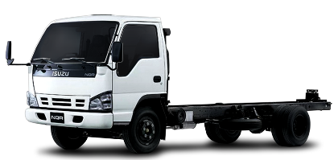
22 | Chassis | ISUZU  NPR 75L-K  (Euro 3) | Overall dimensions (L/W/H)- 6635х2040х2255 mm,  Gross vehicle weight – 7 500 kg ,Chassis weight– 2 705 kg  Engine model – ISUZU 4HK1-TCN, diesel, Euro 3  Maximum power – 110 hp /150 kW (2600 rpm)  Breaking system – drum type with ABS  Fuel tank capacity -100 l | 25 000 | 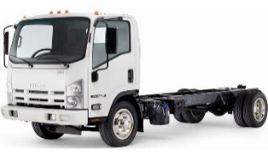
23 | Chassis | ISUZU  NPR 75L-K (Euro 5) | Overall dimensions (L/W/H)- 6635х2040х2255 mm,  Gross vehicle weight – 7 500 kg ,Chassis weight– 2 705 kg  Engine model – ISUZU 4HK1-TCN, diesel, Euro 5  Maximum power – 110 hp /150 kW (2600 rpm)  Breaking system – drum type with ABS  Fuel tank capacity -100 l | 30 500
24 | Lorry with sides | ISUZU  NQR 71PL | Overall dimensions (L/W/H) – 6730 / 2210 / 3098 mm  Payload – 3755 kg,  Engine model – ISUZU 4HG1, diesel, Euro 2  Maximum power – 121 hp /89 kW(3200 rpm)  Wheel base – 2 460 mm  Vehicle control type: Left hand drive | 27 500 | 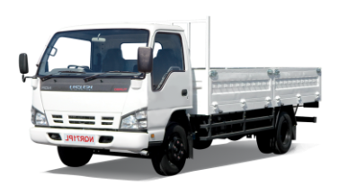
25 | Cargo tent truck | ISUZU  NQR 71PL | Overall dimensions (L/W/H) – 6730 / 2300 / 3098 mm  Payload – 3755 kg, Body space – 20 mc  Engine model – ISUZU 4HG1, diesel, Euro 2  Maximum power – 121 hp /89 kW(3200 rpm)  Vehicle control type: Left hand drive | 29 000 | 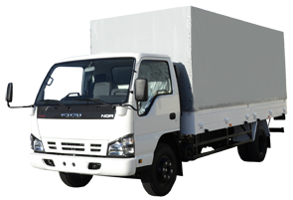
26 | Van | ISUZU  NQR 71PL | Overall dimensions (L/W/H) – 6730 / 2210 / 3098 mm  Payload – 3995 kg, Body space – 20 mc  Engine model – ISUZU 4HG1, diesel, Euro 2  Maximum power – 121 hp /89 kW(3200 rpm)  Vehicle control type: Left hand drive | 29 000 | 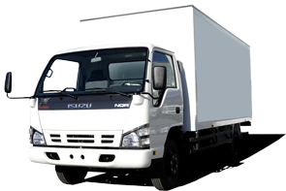
27 | Refrigerated van | ISUZU  NQR 71PL | Overall dimensions (L/W/H) – 6730 / 2240 / 3098 mm  Payload – 3000 kg, Body space – 19 mc  Cooling temperature – (+5С⁰ ÷ -5С⁰) / (0С⁰ ÷ -18С⁰)  Engine model – ISUZU 4HG1, diesel, Euro 2  Maximum power – 121 hp /89 kW(3200 rpm)  Vehicle control type: Left hand drive | 38 000
28 | Beverages van | ISUZU  NQR 71PL | Overall dimensions (L/W/H) – 6580 / 2200 / 2720 mm  Payload – 4200 kg, Body capacity – 6 pallets  Engine model – ISUZU 4HG1, diesel, Euro 2  Maximum power – 121 hp /89 kW(3200 rpm)  Vehicle control type: Left hand drive | 31 000 | 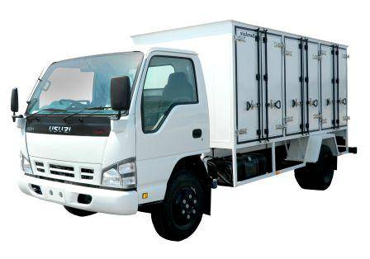
29 | Bakery van | ISUZU  NQR 71PL | Overall dimensions (L/W/H) – 6455 / 2234 / 2250 mm  Payload – 3945 kg  Tray for bakery – 140 trays  Engine model – ISUZU 4HG1, diesel, Euro 2  Maximum power – 121 hp /89 kW(3200 rpm)  Vehicle control type: Left hand drive | 31 000 | 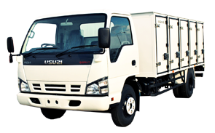
30 | Dump truck | ISUZU  NQR 71PL | Overall dimensions (L/W/H) – 6214 / 2150 / 2454 mm  Payload – 4000 kg  Engine model – ISUZU 4HG1, diesel, Euro 2  Maximum power – 121 hp /89 kW(3200 rpm)  Vehicle control type: Left hand drive | 35 000 | 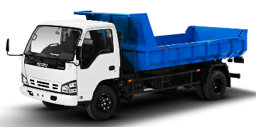
31 | Garbage truck | ISUZU  NQR 71PL | Overall dimensions (L/W/H) – 7130 / 2240 / 2700 mm  Payload – 2020 kg, Body cubic capacity – 7 mc  Engine model – ISUZU 4HG1, diesel, Euro 2  Maximum power – 121 hp /89 kW(3200 rpm)  Vehicle control type: Left hand drive | 44 000 | 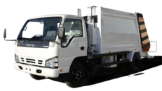
32 | Water carrier | ISUZU  NQR 71PL | Overall dimensions (L/W/H) – 6700 / 2180 / 2560 mm  Tank volume – 4170 l,  Engine model – ISUZU 4HG1, diesel, Euro 2  Maximum power – 121 hp /89 kW(3200 rpm)  Vehicle control type: Left hand drive | 33 000 | 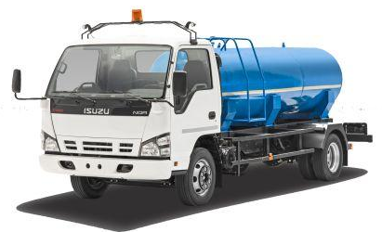
33 | Cesspool cleaner | ISUZU  NQR 71PL | Overall dimensions (L/W/H) – 7060 / 1665 / 2560 mm  Tank volume – 4120 l,  Engine model – ISUZU 4HG1, diesel, Euro 2  Maximum power – 121 hp /89 kW(3200 rpm)  Vehicle control type: Left hand drive | 33 000 | 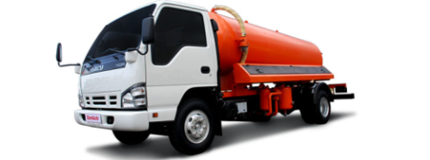
34 | Breakdown truck | ISUZU  NQR 71PL | Overall dimensions (L/W/H) – 7060х1665х2560 mm  Payload – 4 400 kg,  Engine model – ISUZU 4HG1, diesel, Euro 2  Maximum power – 121 hp /89 kW(3200 rpm)  Wheel base – 2 460 mm  Vehicle control type: Left hand drive | 43 000 | 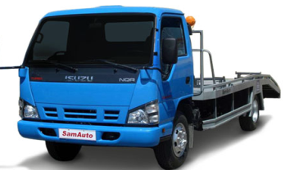
35 | Milk tanker | ISUZU  NQR 71PL | Overall dimensions (L/W/H) – 7060 / 1665 / 2560 mm  Tank volume – 4000 l,  Engine model – ISUZU 4HG1, diesel, Euro 2  Maximum power – 121 hp /89 kW(3200 rpm)  Vehicle control type: Left hand drive | 42 000 | 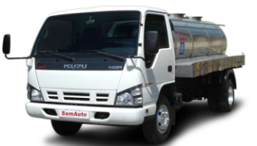
36 | Street washer | ISUZU  NQR 71PL | Overall dimensions (L/W/H) – 7060 / 1665 / 2560 mm  Tank volume – 4120 l,  Engine model – ISUZU 4HG1, diesel, Euro 2  Maximum power – 121 hp /89 kW(3200 rpm)  Wheel base – 2 460 mm  Vehicle control type: Left hand drive | 41 000
37 | Fire-fighting vehicle | ISUZU  NQR 71PL | Overall dimensions (L/W/H) – 6870 / 2150 / 2480 mm  Water tank volume – 1700 liter  Foam tank volume – 150 liter  Engine model –ISUZU 4HG1, diesel, Euro 2  Maximum power – 121 hp /89 kW(3200 rpm)  Vehicle control type: Left hand drive | 152 000 | 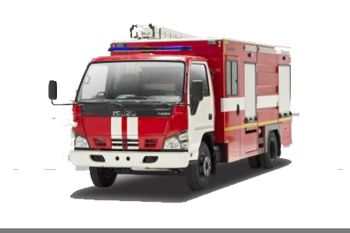
38 | Telescopic tower | ISUZU  NQR 71PL | Overall dimensions (L/W/H) – 7047 / 1995 / 3360 mm,  Basket payload – 250 kg,  Maximum working height – 22m  Engine model –ISUZU 4HG1, diesel, Euro 2  Maximum power – 121 hp /89 kW(3200 rpm) | 79 500 | 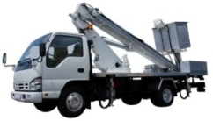
39 | Telescopic tower | ISUZU  NQR 71PL | Overall dimensions (L/W/H) – 7047 / 1995 / 3360 mm,  Basket payload – 200 kg,  Maximum working height – 18m  Engine model –ISUZU 4HG1, diesel, Euro 2  Maximum power – 121 hp /89 kW(3200 rpm) | 72 900
40 | Vacuum cleaning sweeper | ISUZU  NQR 71PL | Overall dimensions (L/W/H) – 6730 / 2210 / 2350 mm,  Water tank volume – 800 liter,  Body cubic capacity – 4 mc  Engine model –ISUZU 4HG1, diesel, Euro 2  Maximum power – 121 hp /89 kW(3200 rpm) | 107 000 | 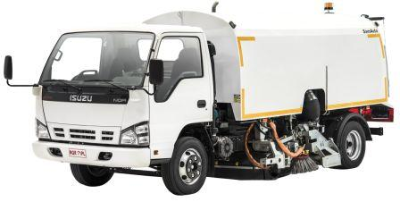
41 | Crane manipulator | ISUZU  NQR 71 PL | Overall dimensions (L/W/H) – 6730х2300х2380 mm  Lifting capacity – 3200 kg  Maximum lift height – 12 m  Maximum working radius – 9,45 m  Engine model – ISUZU 4HG1, diesel, Euro 2  Maximum power – 121 hp /89 kW(3200 rpm) | 50 000 | 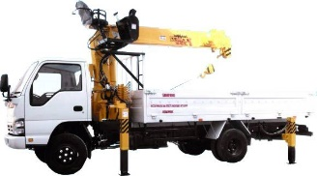
42 | Evacuator with a crane (up to 8.4 m - 1.5 tons) | ISUZU  NQR 71PL | Overall dimensions (L/W/H) – 7060х1665х2560 мм  Lifting capacity – 4400 кг  Tractive force of winch - 3500 kg  Engine - ISUZU 4HG1, diesel, Euro-2  Engine power - 121 HP / 89 kW at 3200 rpm | 72 500 | 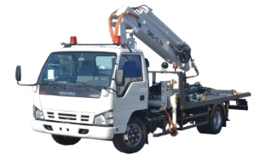
43 | Chassis | ISUZU  FTR 33 HLX | Overall dimensions (L/W/H) – 7420 / 2400 / 2570 mm  Gross vehicle weight – 13 300 kg  Chassis mass – 4780 kg,  Engine model – ISUZU 6HH1-S, diesel, Euro 1  Maximum power – 200 hp / 147 kW (2 850 rpm)  Wheel base – 3650 mm  Fuel tank capacity – 200 liter | 31 000 | 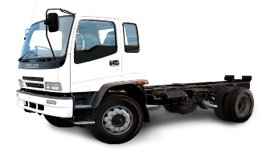
44 | Chassis | ISUZU  FTR 34L-E  (Euro 3) | Overall dimensions (L/W/H)- 7665х2450х2860 mm,  Wheel arrangement - 4 х 2 / rear (dual)  Wheel base – 4 250 mm, Gross vehicle weight – 14 200 kg  Engine model – ISUZU 6HK1-TCN, diesel, Euro 3  Maximum power – 177 hp /240 kW (2400 rpm)  Transmission - ISUZU MZW6P, manual control  Breaking system – drum type with ABS  Fuel tank capacity – 200 liter | 39 000 | 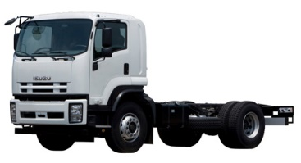
45 | Chassis | ISUZU  FVR 33 GLD | Overall dimensions (L/W/H) – 6770 / 2465 / 2670 mm  Gross vehicle weight – 15 100 kg  Chassis mass – 4880 kg,  Engine model – ISUZU 6HH1-S, diesel, Euro 1  Maximum power – 200 hp / 147 kW (2 850 rpm)  Wheel arrangement 4х2 / rear  Wheel base – 3 900 mm | 36 000 | 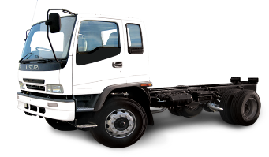
46 | Chassis | ISUZU  FVR 34K-E  (Euro 3) | Overall dimensions (L/W/H) - 6755х2460х2900 mm  Wheel base – 3 900 mm, Gross vehicle weight – 17 000 kg  Engine model – ISUZU 6HK1-TCN, diesel, Euro 3  Maximum power – 177 hp /240 kW (2400 rpm)  Transmission - ISUZU MZW6P, manual control  Breaking system – drum type with ABS  Fuel tank capacity – 200 liter | 41 000
47 | Chassis | ISUZU  FVR 33 PLX | Overall dimensions (L/W/H) – 9270 / 2465 / 2670 mm  Gross vehicle weight – 15 100 kg  Chassis mass – 5130 kg,  Engine model – ISUZU 6HH1-S, diesel, Euro I  Maximum power – 200 hp / 147 kW (2 850 rpm)  Wheel arrangement 4х2 / rear  Wheel base – 5 550 mm  Fuel tank capacity – 200 liter | 37 000 | 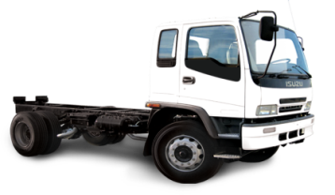
48 | Chassis | ISUZU  FVR 34M-E  (Euro 3) | Overall dimensions (L/W/H) - 7955х2459х2885 mm  Wheel arrangement - 4 х 2 / rear (dual)  Wheel base – 4 650 mm, Gross vehicle weight – 17 000 kg  Engine model – ISUZU 6HK1-TCN, diesel, Euro 3  Maximum power – 221 hp /300 kW (2400 rpm)  Transmission - ZF9S1110, manual control  Breaking system – drum type with ABS  Fuel tank capacity – 200 liter | 54 500 | 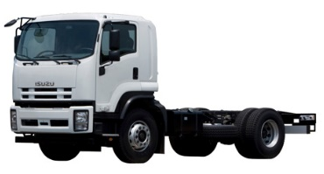
49 | Chassis | ISUZU  FVR 34Q-E  (Euro 3) | Overall dimensions (L/W/H) - 9255х2459х2885 мм,  Wheel arrangement - 4 х 2 / rear (dual)  Wheel base – 5 550 mm, Gross vehicle weight – 17 000 kg  Engine model – ISUZU 6HK1-TCN, diesel, Euro 3  Maximum power – 177 hp /240 kW (2400 rpm)  Transmission - ISUZU MZW6P, manual control  Breaking system – drum type with ABS  Fuel tank capacity – 200 liter | 41 000
50 | Lorry with sides | ISUZU  FVR 33 PLX | Overall dimensions (L/W/H) – 9270 / 2465 / 2670 mm  Payload – 8000 kg  Engine model – ISUZU 6HH1-S, diesel, Euro I  Maximum power – 200 hp / 147 kW (2 850 rpm)  Wheel arrangement 4х2 / rear  Fuel tank capacity – 200 liter | 47 000 | 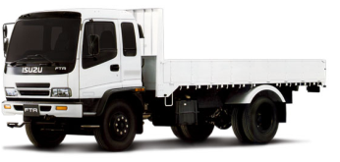
51 | Cargo tent truck | ISUZU  FVR 33 PLX | Overall dimensions (L/W/H) – 9330 / 2490 / 3490 mm  Payload – 7785 kg, Body space – 32 mc  Engine model – ISUZU 6HH1-S, diesel, Euro I  Maximum power – 200 hp / 147 kW (2 850 rpm)  Wheel arrangement 4х2 / rear  Fuel tank capacity – 200 liter | 47 700 | 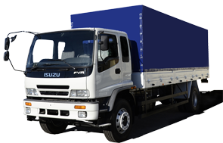
52 | Van | ISUZU  FVR 33 PLX | Overall dimensions (L/W/H) – 9300 / 2490 / 3400 mm  Payload – 7580 kg, Body space – 33 mc  Engine model – ISUZU 6HH1-S, diesel, Euro I  Maximum power – 200 hp / 147 kW (2 850 rpm)  Wheel arrangement 4х2 / rear  Fuel tank capacity – 200 liter | 48 000 | 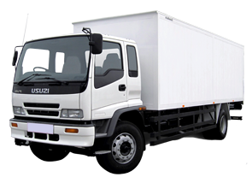
53 | Garbage truck | ISUZU  FVR 33GLD | Overall dimensions (L/W/H) – 8100 / 2450 / 2850 mm  Payload – 6250 kg, Body cubic capacity – 10+1.5 mc  Engine model – ISUZU 6HH1-S, diesel, Euro 1  Maximum power – 200 hp /147 kW(2850 rpm)  Fuel tank capacity – 200 liter | 65 000 | 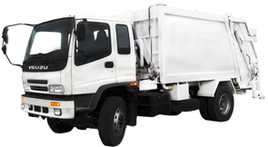
54 | Dump truck | ISUZU  FVR 33GLD | Overall dimensions (L/W/H) – 6500 / 2490 / 2950 mm  Payload – 8000 kg  Engine model – ISUZU 6HH1-S, diesel, Euro I  Maximum power – 200 hp /147 kW(2850 rpm)  Fuel tank capacity – 200 liter | 55 000 | 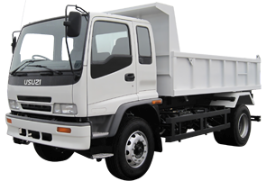
55 | Street sweeper | ISUZU  FVR 33 GLD | Overall dimensions (L/W/H) – 8250 / 2900 / 2960 mm  Water tank volume – 7,4 mc  Engine model – ISUZU 6HH1-S, diesel, Euro I  Maximum power – 200 hp / 147 kW (2 850 rpm)  Working width, m  - washing/watering – 8 / 18 m  - sweeping/cleaning – 2.3 m | 83 000 | 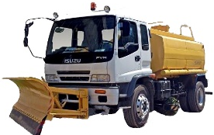
56 | Water carrier | ISUZU  FVR 33 GLD | Overall dimensions (L/W/H) – 8250х2900х2960 мм  Gross vehicle weight – 15 100 kg, Tank volume – 8 mc  Engine model – ISUZU 6HH1-S, diesel, Euro 1  Maximum power – 200 hp / 147 kW (2 850 rpm)  Fuel tank capacity – 200 liter | 61 000 | 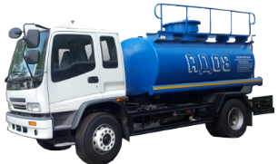
57 | Truck crane | ISUZU  FVR 33GLD | Overall dimensions (L/W/H) – 8250х2900х2960 мм  Gross vehicle weight – 15 100 kg  Lifting capacity – 16 t  Engine model – ISUZU 6HH1-S, diesel, Euro 1  Maximum power – 200 hp / 147 kW (2 850 rpm)  Fuel tank capacity – 200 liter | 103 000 | 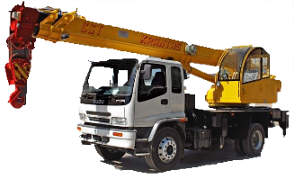
58 | Fuel tanker  (with pump and ТРК) | ISUZU  FVR 34K-E  (Euro 3) | Overall dimensions (L/W/H) – 8 000х2500х3000 mm  Tanker dimensions (L/W/H) – 4000х2300х2000 mm  Tanker volume – 8 mc  Engine model – ISUZU 6HK1-TCN, diesel, Euro 3  Maximum power – 240 hp /177 kW (2400 rpm)  Fuel tank capacity – 200 liter | 69 000 | 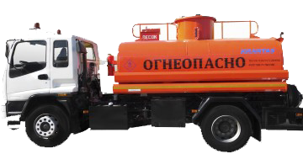
59 | Fire-fighting vehicle | ISUZU  FTR 33HLX | Overall dimensions (L/W/H) – 7750 / 2800 / 3232 mm  Water tank volume – 4000 liter  Foam tank volume – 400 liter  Engine model – ISUZU 6HH1-S, diesel, Euro I  Maximum power – 200 hp /147 kW (2850 rpm) | 167 000 | 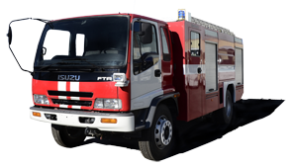
60 | Fire-fighting vehicle | ISUZU  FVR 23K | Overall dimensions (L/W/H) – 8340х2570х3250 mm  Water tank volume – 6000 liter  Foam tank volume – 600 liter  Engine model – ISUZU 6SD1, diesel, Euro 1  Maximum power – 240 hp /177 kW (2500 rpm)  Fuel tank capacity – 200 liter | 194 000
61 | Vacuum cleaning sweeper | ISUZU  FTR 33HLX | Overall dimensions (L/W/H) – 7420 / 2400 / 2570 mm  Water tank volume – 1100 liter  Dustbin capacity - 4 mc  Working surface – 2200 mm.  Engine model – ISUZU 6HH1-S, diesel, Euro I  Maximum power – 200 hp /147 kW (2850 rpm) | 125 700 | 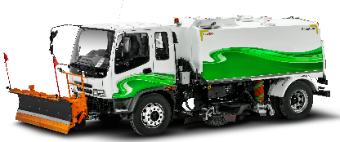
62 | Dump truck | ISUZU  CYZ 51P | Overall dimensions (L/W/H) – 8540х2515х3520 mm  Payload – 20 t  Wheel arrangement – 6х4  Погрузочная высота кузова – 2580 мм,  Engine model – ISUZU 6WF1-TCC, diesel, Euro 2,  Maximum power – 390 hp /287 kW (1800 rpm)  Fuel tank capacity – 400 liter | 91 000 | 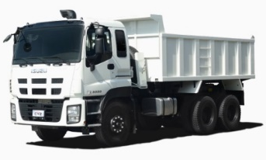
63 | Шасси  грузового автомобиля | ISUZU  NPS 75H  (Евро-3) | Габаритные размеры (ДхШхВ) - 6635х2040х2255 мм,  Полная масса – 6 000 кг, Масса шасси – 2 910 кг,  Двигатель – ISUZU 4HK1-TCN, дизель, Евро-3  Мощность двигателя – 110 кВт/ 150 л.с. (2600 об/мин)  Рабочий объем цилиндров - 5193 см3  Тормозная система – барабанный, с ABS  Ёмкость топливного бака 100 л  Колесная формула – 4х4 | 38 000
64 | Chassis | ISUZU  NPR82 (CNG) | Overall dimensions (L/W/H) – 6635 / 2115 / 2270 mm  Gross vehicle weight – 7 500 kg  Chassis mass – 2 885 kg,  Engine model – ISUZU 4HV1, Euro 4  Maximum power – 131 hp /96 kW(3200 rpm)  Wheel arrangement 4х2 / rear  Wheel base – 3 845 mm  Fuel type – compressed natural gas (CNG) | 33 500 | 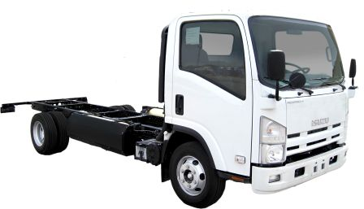

- All prices are performed on FCA basis- LLC “Samarkand Automobile Factory”, Samarkand, Uzbekistan on standard option models for a month after publication from 09/07/2018.

