1 | The names of the company | «NMedov» Ltd.
2 | Brief information about the company (year of establishment, staff, etc.) | «NMedov» Holding was established in 2009. Holding consists of 4 companies:  PE «Chococream» - was founded in 2006, before the holding.  PE «Finland Butter» - was created in 2009,  OOO «Glory Food» was created in 2010  «Ardent Foods» Ltd. - was established in 2013  more than 200 skilled professionals work in the holding.
3 | Company logo
4 | Address | 100161, Republic of Uzbekistan, Tashkent, Chilonzor district, st. Chorbog 53A
5 | FULL NAME. plant manager
6 | Phone | +99871 2790096
7 | Fax | +99871 2790095
8 | E-mail | info@nmedov.uz
9 | Site | http://www.nmedov.uz
10 | manufactured products | Chocolate paste, chocolate, oil and fat products and instant noodles and pasta.
eleven | Quality of products | higher
12 | Volume of production | -
13 | quality certificate | ISO 9001
14 | Packaging | -
15 | Price  (In US $ \ unit of measure.) | Negotiable
16 | Delivery conditions | Negotiable
17 | product photo | 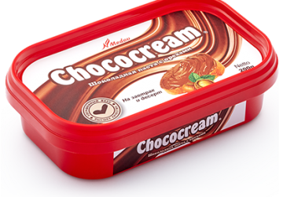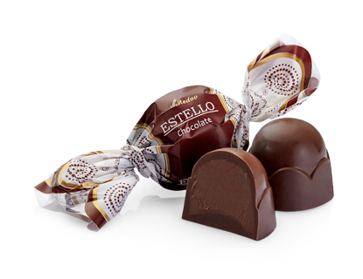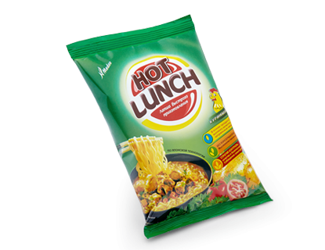
COMMERCIAL PROPOSAL

1 | The names of the company | OOO "Gold Dried Fruits Export"
2 | Brief information about the company (year of establishment, staff, etc.) | OOO "Gold Dried Fruits Export" was founded in 2012
3 | Company logo | 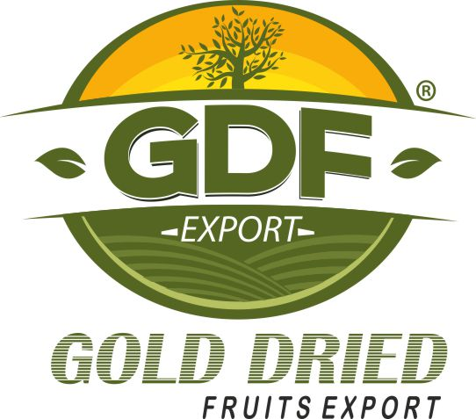
4 | Address | Uzbekistan, Tashkent, st. H. Bayqara, 104 A
5 | FULL NAME. plant manager | Valiev Murodjon
6 | Phone | +99871 295-22-62
7 | Fax | +99871 295-22-60
8 | E-mail | gdfmail@mail.ru, info@gdf.uz
9 | Site | http://gdf.uz
10 | manufactured products | Dried vegetables and herbs.
eleven | Quality of products | higher
12 | Volume of production | 120 tons / day
13 | quality certificate | Global GAP, ISO 22000.
14 | Packaging | -
15 | Price  (In US $ \ unit of measure.) | Negotiable
16 | Delivery conditions | Negotiable
17 | product photo | 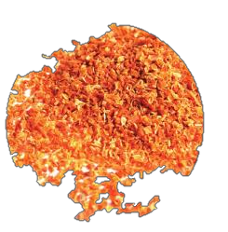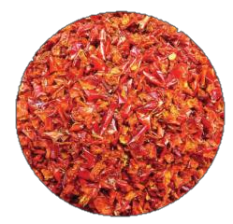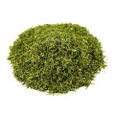
COMMERCIAL PROPOSAL

The names of the company | Ltd. "MAVIS GLOBAL".
Brief information about the company (year of establishment, staff, etc.) | Since 2006, a new trademark "MAVIS"
Company logo
Address | 100210, Republic of Uzbekistan, Tashkent, Zarafshan travel, 39.
FULL NAME. plant manager | Mirzamuhammedov Talat Zahidzhanovich
Phone | +998 71 299 22 66
Fax | +998 71 299 22 66
E-mail | info@mavis.uz
Site | http://www.mavis.uz
manufactured products | Souffles, marshmallows, chocolate, cookies, jellies, caramel, cocoa cream.
Quality of products | higher
Volume of production | -
quality certificate | -
Packaging | -
Price  (In US $ \ unit of measure.) | Negotiable
Delivery conditions | Negotiable
product photo | 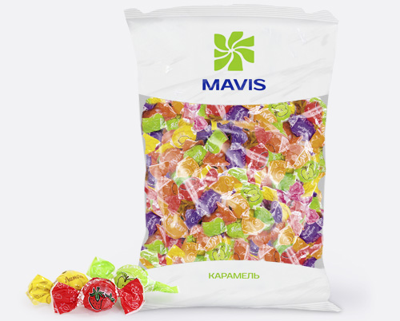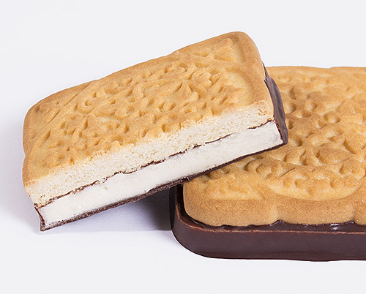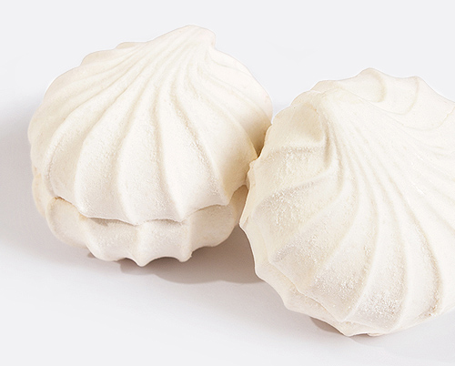

COMMERCIAL PROPOSAL

COMMERCIAL PROPOSAL

The names of the company | OOO «AGROMIR»
Brief information about the company (year of establishment, staff, etc.) | Since 1929 fruktoochistitelny plant was commissioned and produced the first batch of products. It was the company, history and traditions which today continue to staff the joint venture «AGROMIR JUICE» LLC and JV «AGROMIR KONSERVA».
Company logo
Address | Uzbekistan, Tashkent, Yunusobod street Amir Temur
FULL NAME. plant manager | Toshpulatov Kamoliddin
Phone | 998 (71) 140-55-02
Fax | 998 (71) 140-55-02
E-mail | office@agromir.uz  info@agromir.uz
Site | http://agromir.uz
manufactured products | Juices and nectars, canned, juice concentrates, wine production.
Quality of products | higher
Volume of production | -
quality certificate | -
Packaging | -
Price  (In US $ \ unit of measure.) | Negotiable
Delivery conditions | Negotiable
product photo | 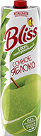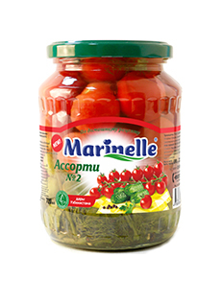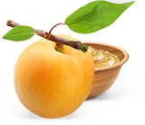

The names of the company | JV Intersok
Brief information about the company (year of establishment, staff, etc.) | Companies «InterSok» was founded in 2004.
Company logo
Address | Uzbekistan, Tashkent  Bektemir district, street. Oltintopgan 18
FULL NAME. plant manager | Khodjaeva Irina
Phone | +998 71 120 37 37
Fax | +998 71 120 37 38
E-mail | Intersok@mail.uz
Site | http://intersok.uz
manufactured products | Juices, snacks, confectionery, dried vegetables, salads.
Quality of products | higher
Volume of production | -
quality certificate | ISO 9001, ISO 22000 / HACCP.
Packaging | -
Price  (In US $ \ unit of measure.) | Negotiable
Delivery conditions | Negotiable
product photo | 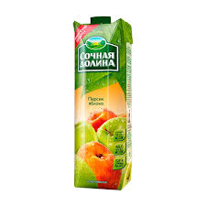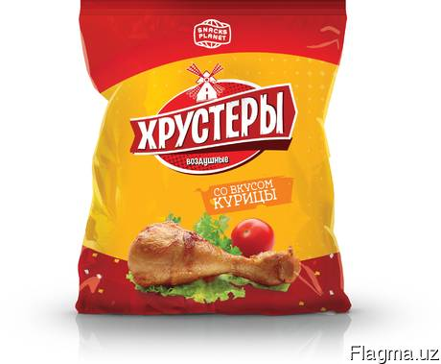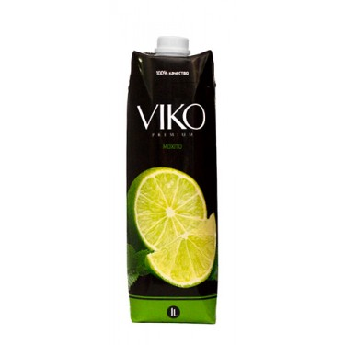

COMMERCIAL PROPOSAL

COMMERCIAL PROPOSAL
The names of the company | FH "SIOB Shavkat ORZU"
Brief information about the company (year of establishment, staff, etc.)
Company logo | 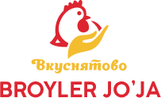
Address | Uzbekistan, Samarkand region, Taylyaksky district, village Kurgancha.
FULL NAME. plant manager
Phone | 998 (66) 666-52-17
Fax | 998 (66) 666-52-18
E-mail | kqm5243@gmail.com
Site | www.vkusnyatovo.uz
manufactured products | Meat products, carcasses broiler chicken breast fillet sliced, steak fillet, chicken wings, chicken, drumstick, broiler chicken
Quality of products | higher
Volume of production | -
quality certificate | -
Packaging | -
Price  (In US $ \ unit of measure.) | Negotiable
Delivery conditions | Negotiable
product photo | 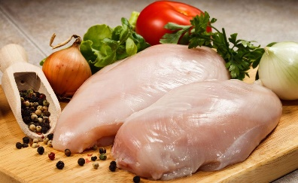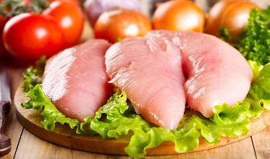

COMMERCIAL PROPOSAL
The names of the company | JV «GREEN WORLD»
Brief information about the company (year of establishment, staff, etc.) | JV «GREEN WORLD» was founded in 1999.
Company logo
Address | Tashkent, Sergelinsky district, street Beshkent, 83
FULL NAME. plant manager | Ismailov Avazhon
Phone | + 99871 290 15 63
Fax | + 99871 290 15 59
E-mail | green-world@bk.ru
Site | http://greenworld.uz
manufactured products | Juices and Nectars, pickles and pickled, puree and concentrates, preserves, jams, stewed fruit, tomato paste.
Quality of products | higher
Volume of production | Recycling pome (apples, pears, grapes, pomegranate) -5 tons per hour;  processing of stone (apricot, peach, plum, cherry) - 5 tons per hour;  tomato paste processing - 5 tons per hour;  Installation aseptic filler with sterilayzerom - 4 tons / hour;
quality certificate | ISO 9001, (FSSC) 22000
Packaging | -
Price  (In US $ \ unit of measure.) | Negotiable
Delivery conditions | Negotiable
product photo
COMMERCIAL PROPOSAL

The names of the company | OOO «Master Delikatesov»
Brief information about the company (year of establishment, staff, etc.) | The history of the plant started in 2003.
Company logo
Address | Tashkent region., Zangiata area  p.Hasanboy, ul.Hamzy 2
FULL NAME. plant manager | Mutalov Otabek
Phone | + (99871) 220-55-77, + (99871) 220-55-00
Fax | + (99871) 220-55-11
E-mail | info@mdelikates.uz
Site | http://mdelikates.uz
manufactured products | Summer sausage, smoked sausages, frankfurters, deli.
Quality of products | higher
Volume of production | -
quality certificate | ISO 9001, ISO 22000: 2009
Packaging | -
Price  (In US $ \ unit of measure.) | Negotiable
Delivery conditions | Negotiable
product photo | 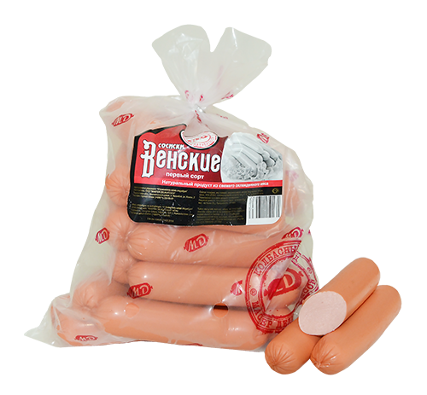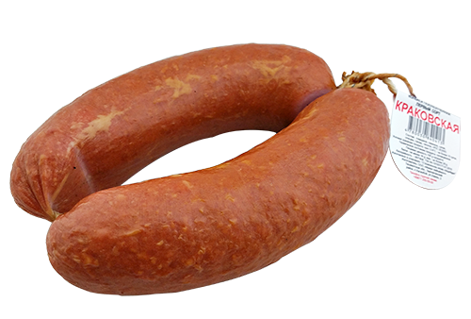

The names of the company | «EastAgroInternational» Ltd.
Brief information about the company (year of establishment, staff, etc.) | Agricultural company «EastAgroInternational» LLC was founded in 2008.
Company logo
Address | Uzbekistan, Kashkadarya region, Shakhrisabz, st. N. Nugaeva 1
FULL NAME. plant manager
Phone | 998 (90) 969-10-15
Fax
E-mail
Site
manufactured products | tomato paste
Quality of products | higher
Volume of production | 30 tons per day of finished products
quality certificate
Packaging
Price  (In US $ \ unit of measure.) | Negotiable
Delivery conditions | Negotiable
product photo | 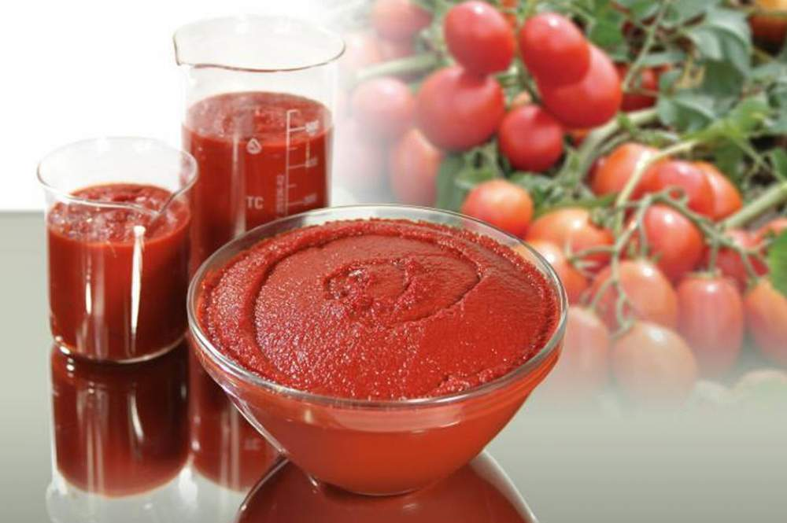
COMMERCIAL PROPOSAL

COMMERCIAL PROPOSAL

The names of the company | PE «ILDIZ PARKENT AGRO»
Brief information about the company (year of establishment, staff, etc.) | PE «ILDIZ PARKENT AGRO» was created in 2007.  Currently, 18 people work in the company.
Company logo
Address | Tashkent region. Parkent district. Pos. Karakalpak, ul. PG-15 Ismatova
FULL NAME. plant manager | Kasimov Jamshid Ilyasovich
Phone | +99871 250 4801; +99899 855 2000
Fax | +998971 250 9397
E-mail | Parkent-agro82@mail.ru
Site | http://ildizparkentagro.uz
manufactured products | Jams baking, condensed milk, gel cake, fruit fillings for milk production.
Quality of products | higher
Volume of production | 100 tons / month of jam "Jam Jam" 50 tons / month skuschenki "Ladybug".
quality certificate | GOST 7009-88
Packaging | -
Price  (In US $ \ unit of measure.) | Negotiable
Delivery conditions | Negotiable
product photo | 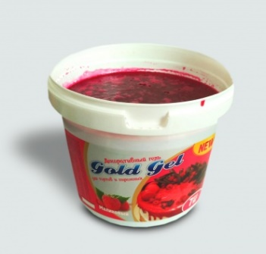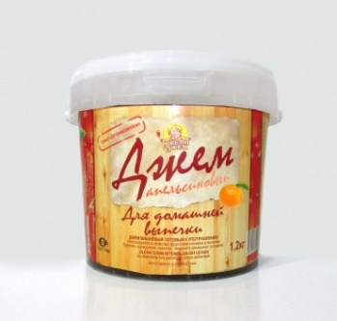

The names of the company | JV «MASTER GLOBAL PLYUS»
Brief information about the company (year of establishment, staff, etc.) | «MASTER GLOBAL PLYUS» The company was founded in 2011.
Company logo
Address | 112000, Uzbekistan, Tashkent region, Yangiyul district, st. Samarkand-57
FULL NAME. plant manager | Sobirjon Obidzhon
Phone | +998 70 602-05-67
Fax | +998 71 227-01-61
E-mail | info@mgp.uz
Site | http://mgp.uz
manufactured products | Juice concentrates, fruit puree and tomato paste.
Quality of products | higher
Volume of production | -
quality certificate | -
Packaging | -
Price  (In US $ \ unit of measure.) | Negotiable
Delivery conditions | Negotiable
product photo | 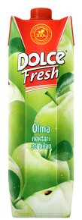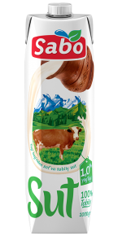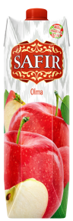
COMMERCIAL PROPOSAL

The names of the company | Ltd "Sunny Fruit Production"
Brief information about the company (year of establishment, staff, etc.) | The company "Sunny Fruit" - founded in 2009.
Company logo
Address | Uzbekistan, Tashkent, Sergiliysky area Saadi Street 41, 100085.
FULL NAME. plant manager
Phone | +99893 171-60-92
Fax | +99871 250-26-30
E-mail | info@sunny-fruits.uz
Site | http://www.sunny-fruits.uz/
manufactured products | Dried fruits and nuts.
Quality of products | higher
Volume of production | -
quality certificate | ISO 9001: 2008, HACCP
Packaging | -
Price  (In US $ \ unit of measure.) | Negotiable
Delivery conditions | Negotiable
product photo | 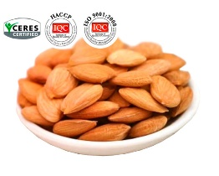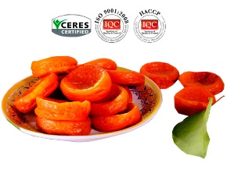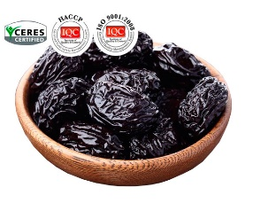
COMMERCIAL PROPOSAL

The names of the company | OOO «Euro food trade»
Brief information about the company (year of establishment, staff, etc.) | The company «Euro food trade» founded in 2001.
Company logo
Address | Uzbekistan, Tashkent, 100080, Uchtepa district, st. Bosithon 16
FULL NAME. plant manager
Phone | 998 (93) 501-13-25
Fax
E-mail
Site
manufactured products | Canned and other foods
Quality of products | higher
Volume of production | -
quality certificate | -
Packaging | -
Price  (In US $ \ unit of measure.) | Negotiable
Delivery conditions | Negotiable
product photo | 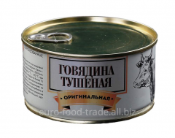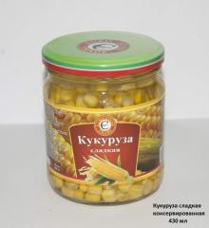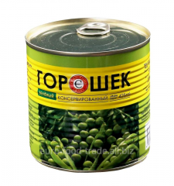
COMMERCIAL PROPOSAL

The names of the company | «Rash-Milk» Ltd.
Brief information about the company (year of establishment, staff, etc.) | Rash-Milk Ltd. was founded in 2003.
Company logo
Address | Uzbekistan, Andizhan region, Buzsky area, MSG Pillakor, Ipak Yuli Street house 131
FULL NAME. plant manager | Ulugbek Mirzaev
Phone | +998 95 200 73 51, +998 95 203 73 62
Fax | 0374 333 17 15
E-mail | info@rash-milk.uz
Site | http://rash-milk.uz
manufactured products | Milk processing and cheese making
Quality of products | higher
Volume of production | -
quality certificate | -
Packaging | -
Price  (In US $ \ unit of measure.) | Negotiable
Delivery conditions | Negotiable
product photo | 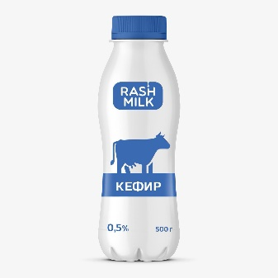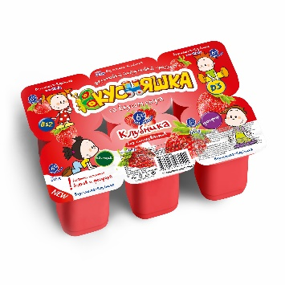
COMMERCIAL PROPOSAL

The names of the company | LLC "Nestle Uzbekistan"
Brief information about the company (year of establishment, staff, etc.) | The company "Nestle Uzbekistan" was established in accordance with the Decree of the Cabinet of Ministers dated October 13, 1999 # 462 "On establishment of the Uzbek-Swiss joint venture Nestlé Uzbekistan MChJ»
Company logo
Address | 100025 Uzbekistan Tashkent street. Abdullah Kahhar, travel 7, 9
FULL NAME. plant manager | Mahkamov Abror Sodikov
Phone | (+99871) 140 06 00
Fax | (+99871) 140 on May 6
E-mail | Nigora.Akilova@uz.nestle.com
Site | https://www.nestle.ru/aboutus/nestle_in_eurasia/uzbekistan
manufactured products | Non-alcoholic drinks; production of mineral waters and other bottled waters.
Quality of products | higher
Volume of production | -
quality certificate | ISO 9001: 2008,
Packaging | -
Price  (In US $ \ unit of measure.) | Negotiable
Delivery conditions | Negotiable
product photo | 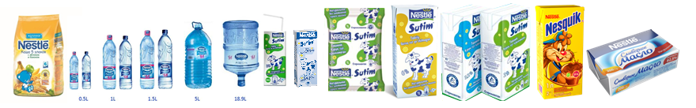
COMMERCIAL PROPOSAL

The names of the company | SP 000 "FRUIT JUICE"
Brief information about the company (year of establishment, staff, etc.) | JV «Fruit Juice» - was founded in 2013.
Company logo
Address | Uzbekistan, Tashkent, Bektemir district, st. H.Baykaro 91
FULL NAME. plant manager
Phone | +998 71 295 12 38
Fax | +998 71 295 11 59
E-mail | ved@fruitjuice.uz
Site | http://fruitjuice.uz
manufactured products | Soft drinks, juices, mineral water, energy drinks.
Quality of products | higher
Volume of production | -
quality certificate | -
Packaging | -
Price  (In US $ \ unit of measure.) | Negotiable
Delivery conditions | Negotiable
product photo | 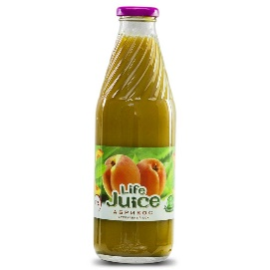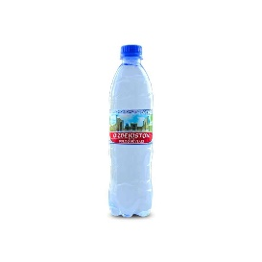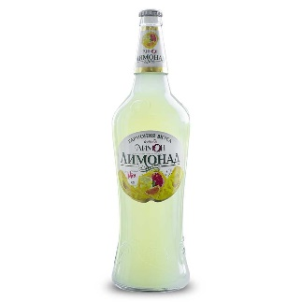
COMMERCIAL PROPOSAL

The names of the company | Ltd. "Kinder Fruits"
Brief information about the company (year of establishment, staff, etc.) | Ltd. "Kinder Fruits" was formed in 27.01.2009godu. The staff consists of 78 people.
Company logo
Address | Tash. region, Yangiyul. The company consists of three branches: Yangiyul, Gazalzhensk (Tash region..), Kattakurgan (Samarkand region).
FULL NAME. plant manager | Akhunzhanov Obidzhon
Phone | +99890 3212929
Fax | +99871 2673060
E-mail
Site
manufactured products | Natural mashed fruit and vegetable based
Quality of products | higher
Volume of production | 5000 tons / month
quality certificate | ISO 9001: 2008,
Packaging | -
Price  (In US $ \ unit of measure.) | Negotiable
Delivery conditions | Negotiable
product photo | 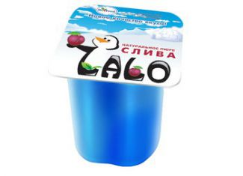
COMMERCIAL PROPOSAL

The names of the company | OOO «Milk Euro Food»
Brief information about the company (year of establishment, staff, etc.) | Joint Uzbek-British-Russian company OOO «Milk Euro Food» is one of the largest producers of butter, spreads and margarine products on the market of the Republic of Uzbekistan in November 2004 c. more than 250 skilled professionals work in the company.
Company logo
Address | 100070, Republic of Uzbekistan, Tashkent, Yakkasaroy district, st. Glinka 18
FULL NAME. plant manager | Dankov Andrew Y.
Phone | (+998 71) 150-56-56
Fax | +998712815741
E-mail | office@milkeurofood.com
Site | https://milkeurofood.com
manufactured products | Butter, spreads and margarine.
Quality of products | higher
Volume of production | 28,000 tons per year of finished products
quality certificate | ISO 9001: 2008 and ISO 22000: 2005
Packaging | From 200 g to 20 kg (foil, parchment and film)
Price  (In US $ \ unit of measure.) | Negotiable
Delivery conditions | Negotiable
product photo | 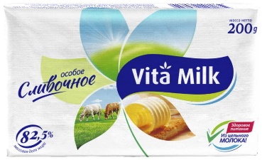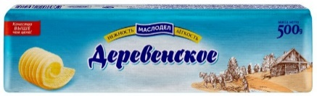
COMMERCIAL PROPOSAL

The names of the company | OOO «Asian Jam»
Brief information about the company (year of establishment, staff, etc.) | LLC «Asian Jam» was created in 2013.
Company logo
Address | 111900, Tashkent region, Yukori Chirchik district, KFY Bardankul street Birlik
FULL NAME. plant manager | Fathullaeva Oksana
Phone | +99895 170-81-01, 382-09-17 +99893
Fax
E-mail | info@asianjam.uz
Site | http://asianjam.uz/
manufactured products | Other processing and preserving of fruit and vegetables
Quality of products | higher
Volume of production | 2,800 kg / day.
quality certificate | -
Packaging | -
Price  (In US $ \ unit of measure.) | Negotiable
Delivery conditions | Negotiable
product photo | 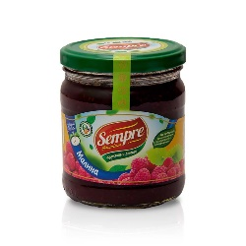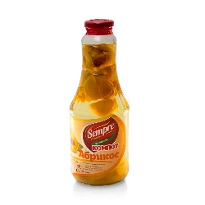
COMMERCIAL PROPOSAL

The names of the company | «INTER-ROXAT»
Brief information about the company (year of establishment, staff, etc.) | Joint Stock Company «INTER-ROXAT» is one of the leading enterprises of the Republic of Uzbekistan food infrastructure for over 40 years!
Company logo
Address | The Republic of Uzbekistan, 111218,  Tashkent region., Kibray district, pos.Salar-HPP
FULL NAME. plant manager | Bobur Alimov Ramuzovich
Phone | +99871 263-95-35
Fax | +99871 263 01 99
E-mail | interrohat@gmail.com
Site | http://inter-rohat.uz
manufactured products | Beer, mineral water, soft drinks
Quality of products | higher
Volume of production | -
quality certificate | -
Packaging | -
Price  (In US $ \ unit of measure.) | Negotiable
Delivery conditions | Negotiable
product photo | 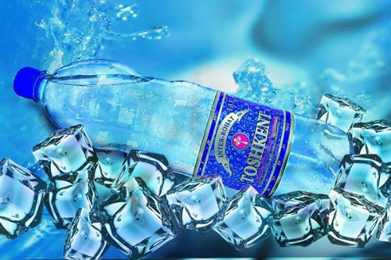
COMMERCIAL PROPOSAL

The names of the company | TEGEN DELIKATES MCHJ
Brief information about the company (year of establishment, staff, etc.) | Company «Tegen» was founded September 1, 1997.
Company logo
Address | Uzbekistan, Tashkent, street Inokobad 10
FULL NAME. plant manager | Edward S. Kim
Phone | + (998) 71 283-46-02
Fax | + (998) 71 283-46-01
E-mail | Info@tegen.uz  tegen@gmail.com
Site | http://tegen.uz
manufactured products | Production of salted, in brine, dried or smoked meat, poultry, meat and edible offal
Quality of products | higher
Volume of production | -
quality certificate | ISO 9001: 2008,
Packaging | -
Price  (In US $ \ unit of measure.) | Negotiable
Delivery conditions | Negotiable
product photo | 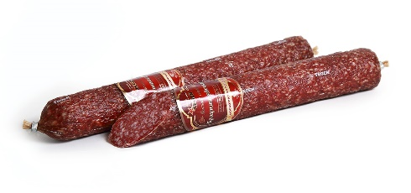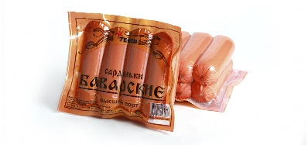
COMMERCIAL PROPOSAL

The names of the company | OOO «CLASS-FOOD-SERVIS»
Brief information about the company (year of establishment, staff, etc.) | Confectionery factory «YOSHLAR» (OOO «CLASS-FOOD-SERVIS»), founded in 2003.
Company logo | 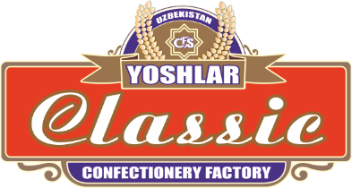
Address | Tashkent region, Zangiata district, street "Shifobahsh suvlar" 48
FULL NAME. plant manager | Rakhmatullaev Faizullah
Phone | +998712268470
Fax
E-mail | yoshlar777@mail.ru
Site | http://classfood.uz
manufactured products | cocoa, chocolate and sugar confectionery
Quality of products | higher
Volume of production | -
quality certificate | -
Packaging | -
Price  (In US $ \ unit of measure.) | Negotiable
Delivery conditions | Negotiable
product photo | 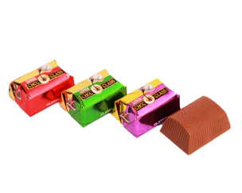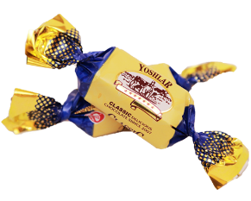
COMMERCIAL PROPOSAL

The names of the company | «FAYZ DEKOR BIZNES» Ltd.
Brief information about the company (year of establishment, staff, etc.) | Uzbek-British joint venture company «FAYZ DEKOR BIZNES» was founded in 2006.
Company logo
Address | Uzbekistan, Tashkent, Sergely district, st. Oltin Vodiy, 3 Proezd 2
FULL NAME. plant manager | Dostmuhamedov Husniddin
Phone | +998 71 250 95 10
Fax | +998 71 250 75 75
E-mail | fayz_tra@dostlink.net
Site | http://www.fayzdekor.com
manufactured products | cocoa, chocolate and sugar confectionery.
Quality of products | higher
Volume of production | -
quality certificate | ISO 9001: 2008.
Packaging | -
Price  (In US $ \ unit of measure.) | Negotiable
Delivery conditions | Negotiable
product photo | 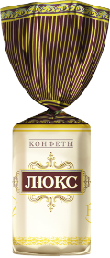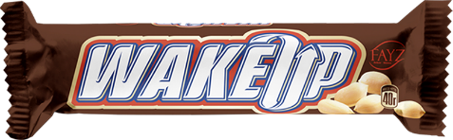
COMMERCIAL PROPOSAL

The names of the company | "World of fairy tales"
Brief information about the company (year of establishment, staff, etc.) | Confectionary "world of fairy tales" is a dynamically developing company for the production of confectionery products, manufactured products since 2001.
Company logo
Address | Tashkent Chilonzor region,  Str. Bogustan 17a
FULL NAME. plant manager | Ergashev Kozimzhon Ergash coals
Phone | (+99871) 2735275
Fax | (+99871) 2782479
E-mail | mchjmirskazok@gmail.com
Site | http://mirskazok.uz
manufactured products | cocoa, chocolate and sugar confectionery.
Quality of products | higher
Volume of production | -
quality certificate | -
Packaging | -
Price  (In US $ \ unit of measure.) | Negotiable
Delivery conditions | Negotiable
product photo | 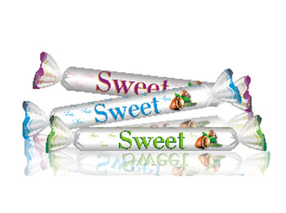
COMMERCIAL PROPOSAL

The names of the company | "Global Invest Import"
Brief information about the company (year of establishment, staff, etc.) | The company "Global Invest Import" is engaged in import Ceylon tea "Mahmood" in 2012.
Company logo
Address | Sergeli - 8, 46 ul.Shakir Aryk, Uzbekistan
FULL NAME. plant manager | Khasanov Nematulla Husanovich
Phone | + 998-71-2004400  + 998-93-3870048
Fax | + 998-71-2151403
E-mail
Site | http://globalinvest.gl.uz
manufactured products | Manufacture / import of dried plodoovoshnoy products.
Quality of products | higher
Volume of production | -
quality certificate | -
Packaging | -
Price  (In US $ \ unit of measure.) | Negotiable
Delivery conditions | Negotiable
product photo
COMMERCIAL PROPOSAL

The names of the company | Ltd. "KRISTAL KONSERVA BIZNES"
Brief information about the company (year of establishment, staff, etc.)
Company logo
Address | Tashkent region., Yangiyul district, st. A. Kahhorov, Building 50
FULL NAME. plant manager | Mirzamuhamedov Alisher Tulkinzhanovich
Phone | 998 (97) 604-68-78
Fax
E-mail | kristalkonserva@mail.ru
Site | kristalkonserva.u
manufactured products | Production of canned fruits and vegetables
Quality of products | higher
Volume of production | -
quality certificate | -
Packaging | -
Price  (In US $ \ unit of measure.) | Negotiable
Delivery conditions | Negotiable
product photo | 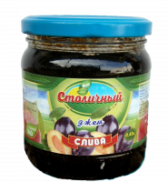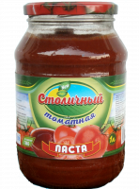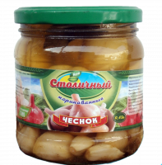
COMMERCIAL PROPOSAL

The names of the company | Ltd "Best tastes technology"
Brief information about the company (year of establishment, staff, etc.) | Company «BEST TASTES TECHNOLOGY» - is considered to be a major producer of natural and high-quality dried fruits in Uzbekistan was founded in 2016.
Company logo
Address | Uzbekistan, Tashkent region, Zangiata district, st. Temur, 102 A
FULL NAME. plant manager | Mirzarahmedov Tahir.Temirovich
Phone | (+998 90) 979-56-66, (+998 99) 811-50-05
Fax
E-mail | uzkand@mail.ru
Site | http://uzkand.uz
manufactured products | Drying of fruits and vegetables
Quality of products | higher
Volume of production | -
quality certificate | -
Packaging | -
Price  (In US $ \ unit of measure.) | Negotiable
Delivery conditions | Negotiable
product photo | 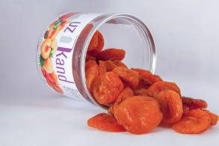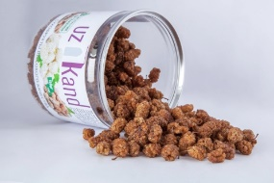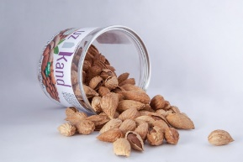
COMMERCIAL PROPOSAL

The names of the company | PE "BAXT"
Brief information about the company (year of establishment, staff, etc.) | "Bakht" private enterprise was founded in 1995
Company logo
Address | 140415, Samarkand region, Jomboy District, village Kangly, mahalla Yangi Hayot
FULL NAME. plant manager | Musinoa Bahtor Muhamadzhanovich
Phone | +998 98 273-22-71  +998 95 500-74-49
Fax
E-mail | info@baht.uz
Site | http://www.baht.uz/
manufactured products | Wholesale of meat and meat products.
Quality of products | higher
Volume of production | -
quality certificate | -
Packaging | -
Price  (In US $ \ unit of measure.) | Negotiable
Delivery conditions | Negotiable
product photo | 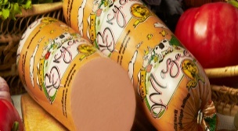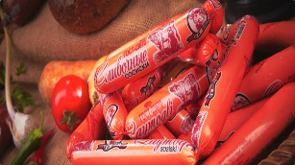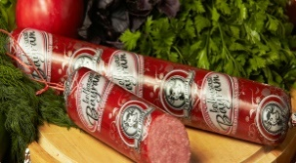
COMMERCIAL PROPOSAL

The names of the company | "TILLAXON" XK
Brief information about the company (year of establishment, staff, etc.) | "Tillaxon" company - a private company, which was founded in 1992.
Company logo
Address | Yangikurgan District, village Istiklol, Yukori Korayantok Uzbekistan
FULL NAME. plant manager | Burhanov Gulomjon Odilbekovich
Phone | + 99897-2303073, + 99897-2514706, + 99894-1590600
Fax
E-mail | info@tillaxon.uz
Site | www.tillaxon.uz
manufactured products | Bakery products and wood processing.
Quality of products | higher
Volume of production | -
quality certificate | -
Packaging | -
Price  (In US $ \ unit of measure.) | Negotiable
Delivery conditions | Negotiable
product photo | 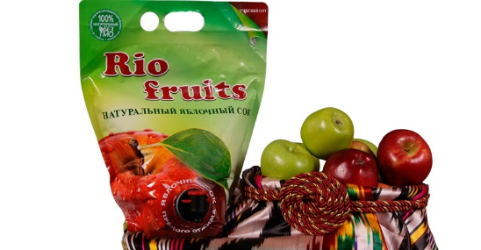
COMMERCIAL PROPOSAL

The names of the company | F / X «Siyob shavkat orzu»
Brief information about the company (year of establishment, staff, etc.) | «Siyob shavkat orzu» was founded in 2013.
Company logo
Address | Uzbekistan, Samarkand, Taylyaksky district, village Kurgancha.
FULL NAME. plant manager
Phone | + (998) 98 180-66-55; + (998) 93 550-74-70; + (998) 91 720-74-70
Fax
E-mail | info@puremilky.uz
Site | http://www.puremilky.uz
manufactured products | Natural dairy, oil and fat products
Quality of products | higher
Volume of production | -
quality certificate | -
Packaging | -
Price  (In US $ \ unit of measure.) | Negotiable
Delivery conditions | Negotiable
product photo | 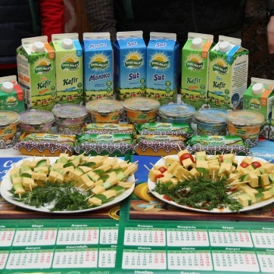
COMMERCIAL PROPOSAL

The names of the company | JV «MUZIMPEX» Ltd.
Brief information about the company (year of establishment, staff, etc.) | JV «MUZIMPEX», created in 2001.
Company logo
Address | Str. Loyhachi, 11, Tashkent region., Nazarbek, 102043, Uzbekistan
FULL NAME. plant manager
Phone | + 998 71 150 88 51
Fax | + 998 71 150 88 52
E-mail | muzimpex@gmail.com
Site | http://muzimpex.agroserver.ru/
manufactured products | Processed agricultural products
Quality of products | higher
Volume of production | 2000 tons / year
quality certificate | -
Packaging | -
Price  (In US $ \ unit of measure.) | Negotiable
Delivery conditions | Negotiable
product photo
COMMERCIAL PROPOSAL

The names of the company | OOO "Elit Konserva"
Brief information about the company (year of establishment, staff, etc.) | "Elite conservative" company was founded in 1996.
Company logo
Address | Tashkent city, Mirabad district, street Hushnud 76.
FULL NAME. plant manager
Phone | + (998 90) 167 33 11
Fax | + (998 71) 290 54 05
E-mail | info@elitkonserva.uz
Site | http://elitkonserva.uz
manufactured products | Products for canning
Quality of products | higher
Volume of production | -
quality certificate | -
Packaging | -
Price  (In US $ \ unit of measure.) | Negotiable
Delivery conditions | Negotiable
product photo | 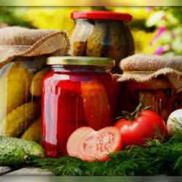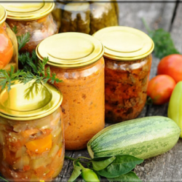
COMMERCIAL PROPOSAL

The names of the company | OOO "Premium Agro Product"
Brief information about the company (year of establishment, staff, etc.) | The company was founded in 2016 in the sunny city of Tashkent.
Company logo
Address | Tashkent, Sergeli-8, Str. Shakir 46 Aryk
FULL NAME. plant manager
Phone | +998 71 200 44 00  +998 93 387 00 41
Fax | +998 71 215 14 05
E-mail | nfo@pap.uz
Site | http://pap.uz
manufactured products | Susheny vegetables
Quality of products | higher
Volume of production | -
quality certificate | -
Packaging | -
Price  (In US $ \ unit of measure.) | Negotiable
Delivery conditions | Negotiable
product photo | 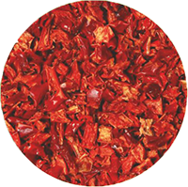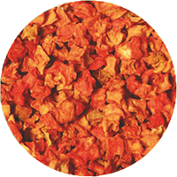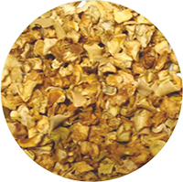
COMMERCIAL PROPOSAL

The names of the company | «PANDA SANOAT SAVDO» Ltd.
Brief information about the company (year of establishment, staff, etc.) | LLC "Panda Sanoat Savdo" exists in the market since 2007.
Company logo
Address | 160019, Uzbekistan Namangan region., Namangan street. Navoi / 12
FULL NAME. plant manager
Phone | + (998 95) 303 88 44
Fax
E-mail | pandasanoatsavdo@gmail.com
Site | pandasanoatsavdo.uz
manufactured products | Candies, cookies, wafers
Quality of products | higher
Volume of production | -
quality certificate | -
Packaging | -
Price  (In US $ \ unit of measure.) | Negotiable
Delivery conditions | Negotiable
product photo | 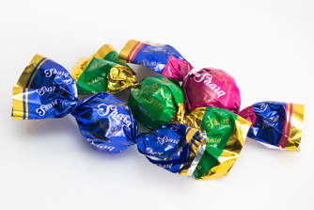
COMMERCIAL PROPOSAL

The names of the company | «ZEBINISO ONA»
Brief information about the company (year of establishment, staff, etc.) | ZEBINISO ONA was founded in 1998
Company logo
Address | Tashkent, Uchtepa district, ul.Uygura TKAD 27
FULL NAME. plant manager
Phone | +998 90 993 00 50  +998 98 364 25 25
Fax | +998 71 247 73 68
E-mail
Site | http://zebiniso-ona.uz
manufactured products | Confectionery
Quality of products | higher
Volume of production | -
quality certificate | -
Packaging | -
Price  (In US $ \ unit of measure.) | Negotiable
Delivery conditions | Negotiable
product photo
COMMERCIAL PROPOSAL

The names of the company | «Candy Gold»
Brief information about the company (year of establishment, staff, etc.) | The company has been operating for over 15 years.
Company logo
Address | Uzbekistan, Tashkent, Almazar P-H str. Oltinsoy 2.
FULL NAME. plant manager
Phone | 998 (98) 367-07-90, 998 (90) 941-17-10
Fax
E-mail | candygold@mail.ru
Site | http://candy-gold.uz
manufactured products | Confectionery
Quality of products | higher
Volume of production | -
quality certificate | -
Packaging | -
Price  (In US $ \ unit of measure.) | Negotiable
Delivery conditions | Negotiable
product photo
COMMERCIAL PROPOSAL

The names of the company | "Zarkent BUSINESS"
Brief information about the company (year of establishment, staff, etc.) | Company "Zarkent BUSINESS" Limited Liability Company is a developing manufacturer of confectionery products in Uzbekistan, leading operations for 8 years.
Company logo
Address
FULL NAME. plant manager
Phone | (71) 228 56 40
Fax
E-mail | info@zarqand.uz
Site | http://zarqand.uz/
manufactured products | Confectionery
Quality of products | higher
Volume of production | -
quality certificate | -
Packaging | -
Price  (In US $ \ unit of measure.) | Negotiable
Delivery conditions | Negotiable
product photo | 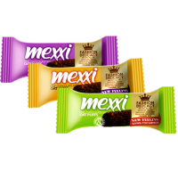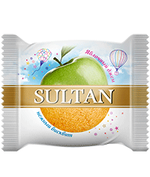
COMMERCIAL PROPOSAL

The names of the company | «Premium Eco Product»
Brief information about the company (year of establishment, staff, etc.) | «Premium Eco Product» was founded in 2015.
Company logo
Address | Str. Bogichinor, d. 25 C-3 array satellite, Sergely, 100102 Tashkent,
FULL NAME. plant manager | Jahongir
Phone | +998 97 761-14-88
Fax | +998 71 257-76-26
E-mail | info@happylife.uz
Site | http://happylife.uz
manufactured products | Concentrate juices
Quality of products | higher
Volume of production | -
quality certificate | -
Packaging | -
Price  (In US $ \ unit of measure.) | Negotiable
Delivery conditions | Negotiable
product photo | 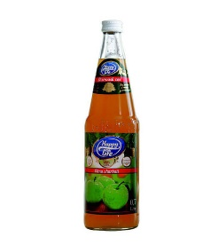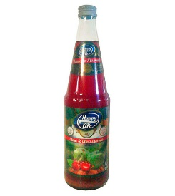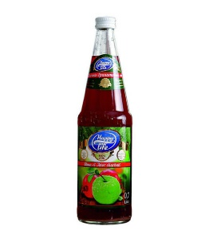
COMMERCIAL PROPOSAL

The names of the company | PE «TILLO DOMOR»
Brief information about the company (year of establishment, staff, etc.) | Initially, in 2000, Sharipov Umarbekov Kuranbaevich being a private individual entrepreneur began operations on processing of 150 liters of milk per day.
Company logo
Address | Khorezm region, Urgench city, street Yangi-Shavot 21,
FULL NAME. plant manager | Sharipov Umarbekov Kuranbaevich
Phone | 998 (362)352-05-05
Fax
E-mail | tillodomor@rambler.ru
Site | http://tillodomor.uz
manufactured products | Processing of milk, fresh dairy products and cheeses.
Quality of products | higher
Volume of production | -
quality certificate | -
Packaging | -
Price  (In US $ \ unit of measure.) | Negotiable
Delivery conditions | Negotiable
product photo | 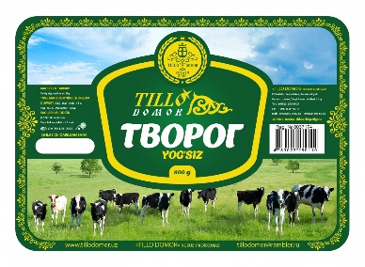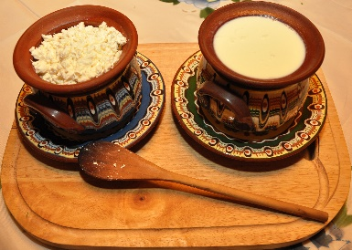
COMMERCIAL PROPOSAL

The names of the company | Ltd. "Marwin Brands"
Brief information about the company (year of establishment, staff, etc.) | Marwin Brands - was founded July 27, 2007.
Company logo | 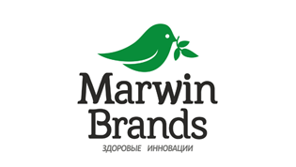
Address | 111902, Tashkent region, Yukori Chirchik district, street Etirof 15
FULL NAME. plant manager | Kuryazov Sherzod
Phone | +99871 230 4000; +99871 230 2000
Fax | +99871 230 2300
E-mail | info@marwin.uz
Site | http://marwin.uz
manufactured products | healthy foods fruit-based: natural juices and nectars.
Quality of products | higher
Volume of production | -
quality certificate | -
Packaging | -
Price  (In US $ \ unit of measure.) | Negotiable
Delivery conditions | Negotiable
product photo | 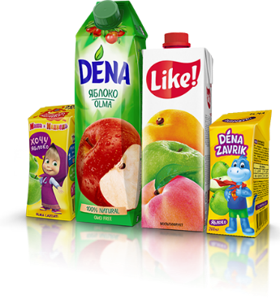
COMMERCIAL PROPOSAL

