Best Navy Textile
“Best Navy Textile”
28 block, Uchtepa District, Tashkent City
Phone number: 998 (97)9270789
“Best Navy Textile”
28 block, Uchtepa District, Tashkent City
Phone number: 998 (97)9270789

COMMERCIAL OFFER

Company “Best Navy Textile” expresses its highest respect to your company and offers high-quality clothing products of its own manufacture.

Our products include kids, women’s and men’s clothing lines: t-shirts, polo’s, tops pajamas, hoodies, sweatshirts, underwear, blouses and other clothing items.

New technological equipment allows expanding the model range. Our skilled designers will assist you in the development new models of clothing and in the creation of new patterns.

We offer our clothing products for customers who values the quality of the item.

We are sending you our assortment of clothing products for consideration at the following prices below:

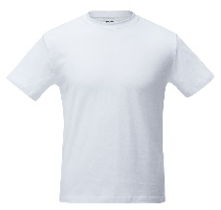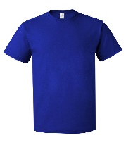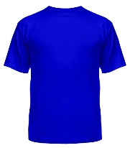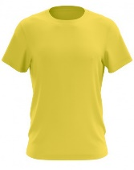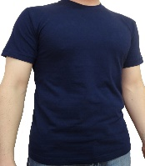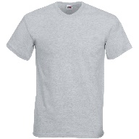

- Men’s T-shirt. Made from 100% cotton Surface density not less than 145 g/sq.m. Quality: Karde. Сolor: white. Price: 2,4$.
- Men’s T-shirt . Made from 100% cotton. Surface density not less than 145 g/sq.m. Quality: Karde. Color: different colors. Price: 2,7$.
- Men’s T-shirt . Made from 100% cotton. Surface density not less than 145 g/sq.m. Quality: Long cotton fiber. Color: white. Price: 2,5$.
- Men’s T-shirt . Made from 100% cotton. Surface density not less than 145 g/sq.m. Quality: Long cotton fiber. Color: different colors. Price: 2,8$.
- Men’s T-shirt. Made from 100% cotton. Surface density not less than 160 g/sq.m. Quality: Karde. Color: white. Price: 2,6$.
- Men’s T-shirt . Made from 100% cotton. Surface density not less than 160 g/sq.m. Quality: Karde. Color: different colors. Price: 2,9$.
- Men’s T-shirt . Made from 100% cotton. Surface density not less than 160 g/sq.m. Quality: Long cotton fiber. Color: white. Price: 2,7$.
- Men’s T-shirt . Made from 100% cotton. Surface density not less than 160 g/sq.m. Quality: Long cotton fiber. Color: different colors. Price: 3,0$.

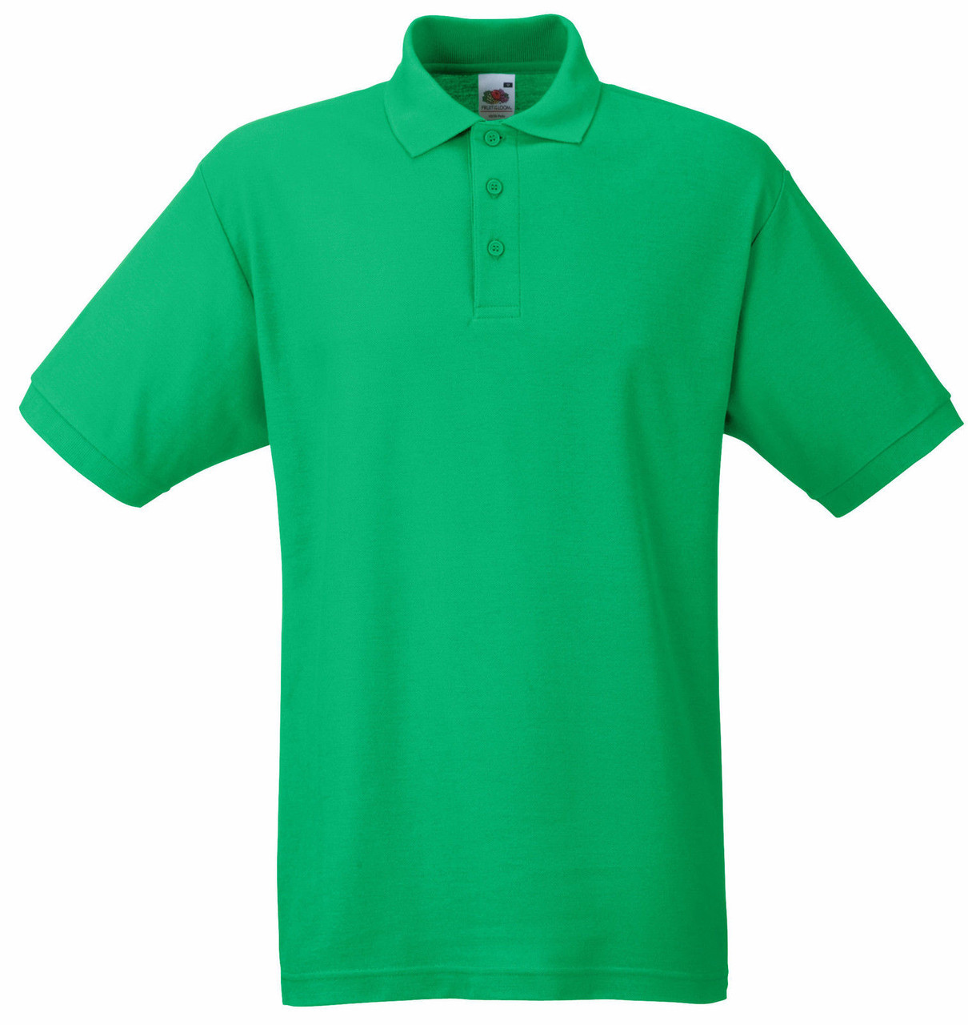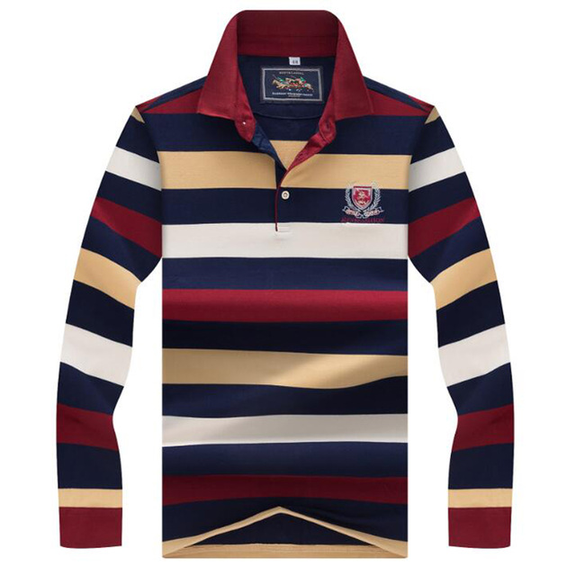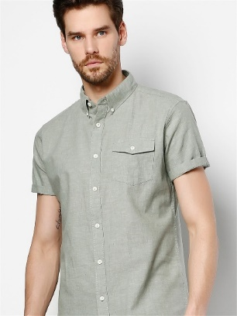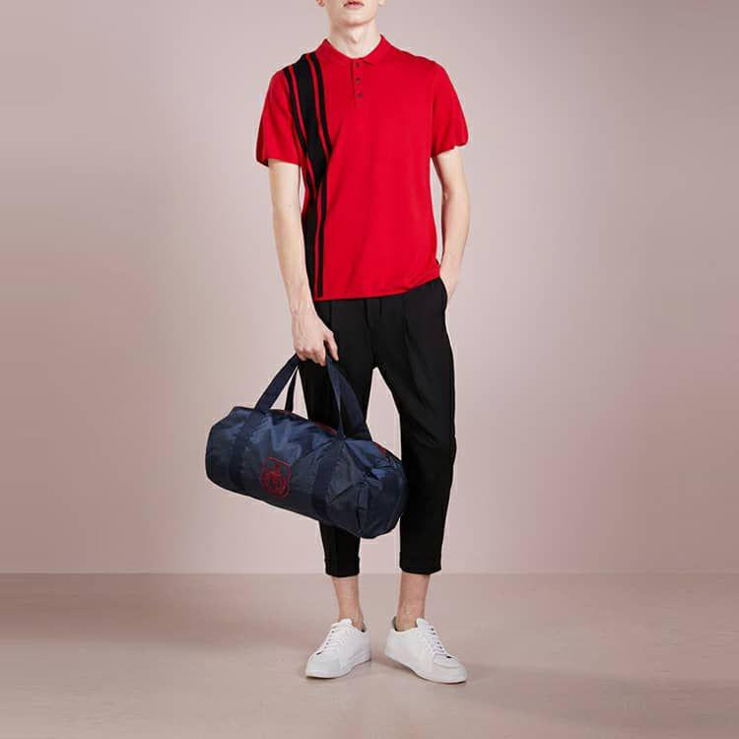

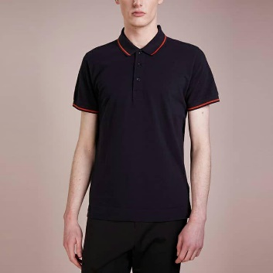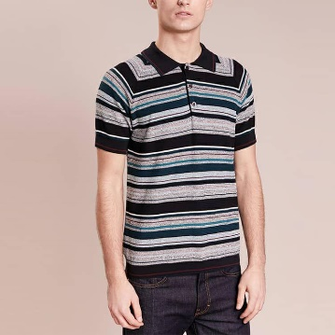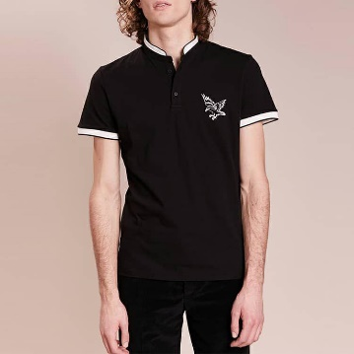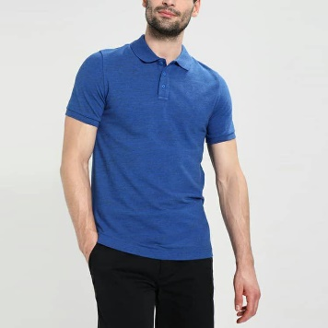
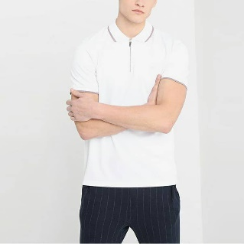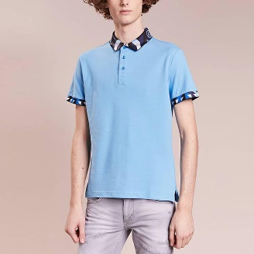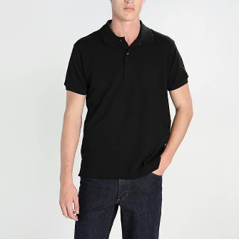
- Men’s polo. Made from 100% cotton. Surface density not less than 170 g/sq.m. Quality: Karde. Color: white. Price: 3,9$.
- Men’s polo. Made from 100% cotton. Surface density not less than 170 g/sq.m. Quality: Karde. Color: white. Price: 4,2$.
- Men’s polo. Made from 100% cotton. Surface density not less than 170 g/sq.m. Quality: Long cotton fiber. Color: white. Price: 4,0$.
- Men’s polo. Made from 100% cotton. Surface density not less than 170 g/sq.m. Quality: Long cotton fiber. Color: white. Price: 4,3$.
- Men’s polo. Made from 100% cotton. Surface density not less than 200 g/sq.m. Quality: Karde. Color: white. Price: 4,2$.
- Men’s polo. Made from 100% cotton. Surface density not less than 200 g/sq.m. Quality: Karde. Color: white. Price: 4,5$.
- Men’s polo. Made from 100% cotton. Surface density not less than 200 g/sq.m. Quality: Long cotton fiber. Color: white. Price: 4,3$.
- Men’s polo. Made from 100% cotton. Surface density not less than 200 g/sq.m. Quality: Long cotton fiber. Color: white. Price: 4,6$.

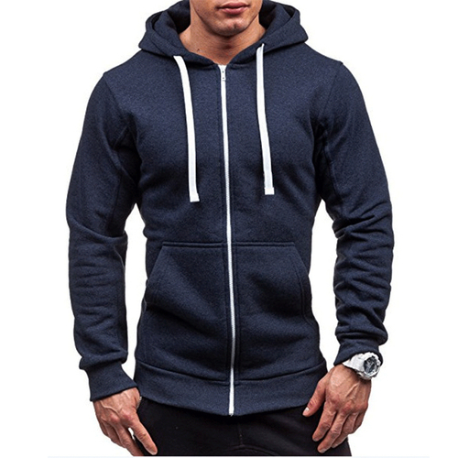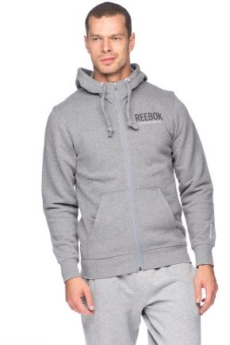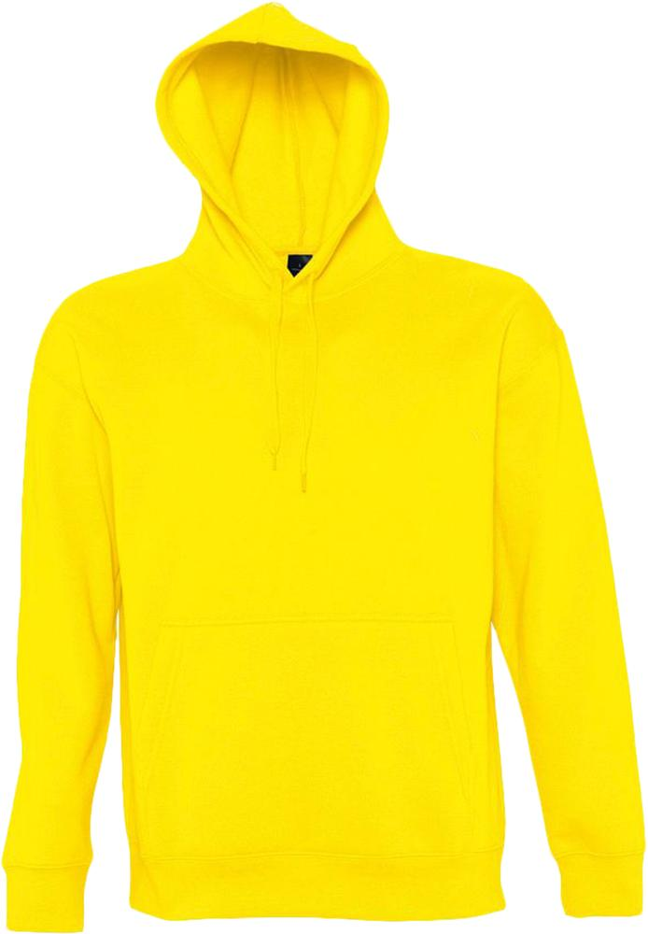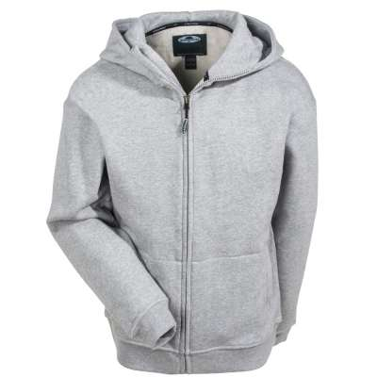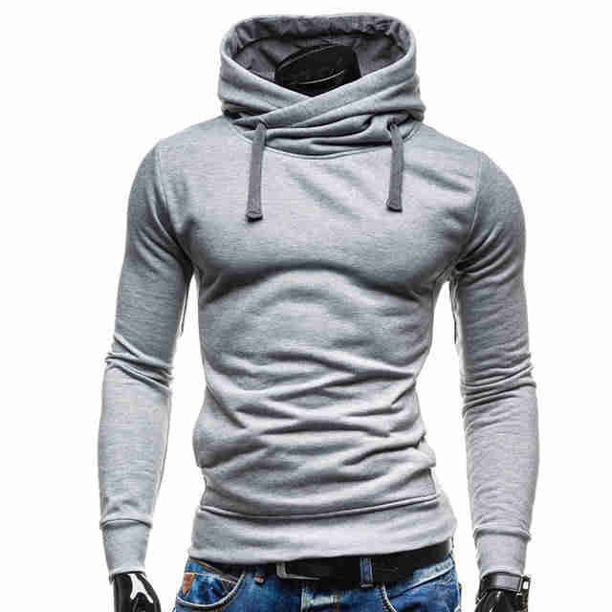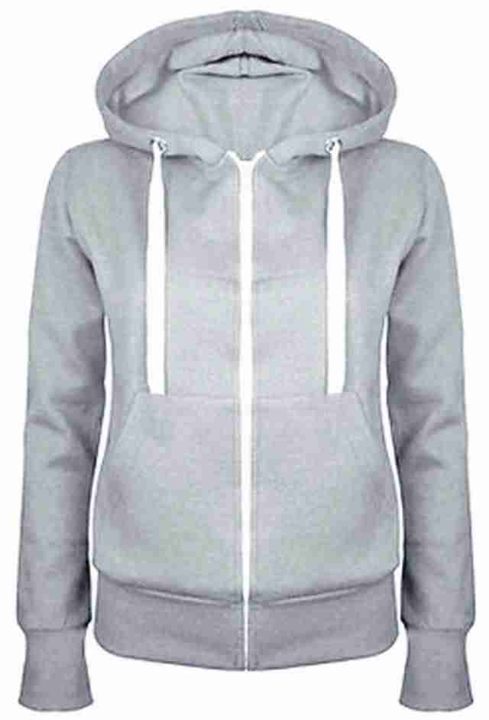

- Men’s Hoddie. Made from 100% cotton. Surface density not less than 250 g/sq.m. Quality: Karde. Color: white. Price: 5,6$.

- Men’s Hoddie. Made from 100% cotton. Surface density not less than 250 g/sq.m. Quality: Karde. Color: different colors. Price: 5,9$.

- Men’s Hoddie. Made from 100% cotton. Surface density not less than 250 g/sq.m. Quality: Long cotton fiber. Color: white. Price: 5,7$.

- Men’s Hoddie. Made from 100% cotton. Surface density not less than 250 g/sq.m. Quality: Long cotton fiber. Color: different colors. Price: 6,0$.

- Men’s Hoddie. Made from 100% cotton. Surface density not less than 300 g/sq.m. Quality: Karde. Color: white. Price: 6,6$.

- Men’s Hoddie. Made from 100% cotton. Surface density not less than 300 g/sq.m. Quality: Karde. Color: different colors. Price: 6,9$.

- Men’s Hoddie. Made from 100% cotton. Surface density not less than 300 g/sq.m. Quality: Long cotton fiber. Color: white. Price: 6,7$

- Men’s Hoddie. Made from 100% cotton. Surface density not less than 300 g/sq.m. Quality: Long cotton fiber. Color: different colors. Price: 7,0$.

- Men’s Hoddie. Made from 100% cotton. Surface density not less than 350 g/sq.m. Quality: Karde. Color: white. Price: 7,6$.

- Men’s Hoddie. Made from 100% cotton. Surface density not less than 350 g/sq.m. Quality: Karde. Color: different colors. Price: 7,9$.

- Men’s Hoddie. Made from 100% cotton. Surface density not less than 350 g/sq.m. Quality: Long cotton fiber. Color: white. Price: 7,7$.

- Men’s Hoddie. Made from 100% cotton. Surface density not less than 350 g/sq.m. Quality: Long cotton fiber. Color: different colors. Price: 8,0$.

Prices are valid for 15 days.

We are looking forward for cooperation.

Sincerely,

Director Abedov N.Х

