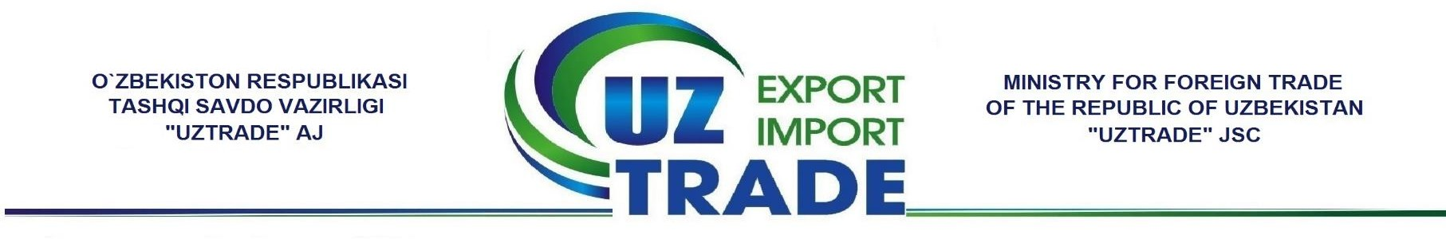

Commercial Offer
04.07.2018г.
«UZTRADE» Joint Stock Company expresses its highest respect to your company and informs that the company operates under the Ministry for Foreign Trade of the Republic of Uzbekistan and offers you oil products produced in the Republic of Uzbekistan.
We offer you the following products.

№ | Product name | Packaging type | FCA Price | Photos
1 | Bulb onions | Mesh Bag | 60 | 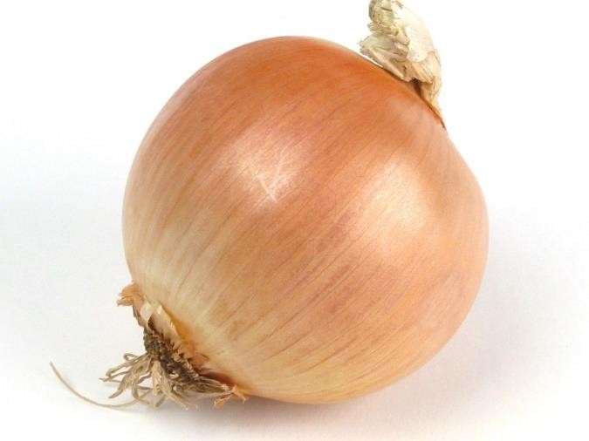

2 | Sesame dark (black-brown) | Bag | 1,20 | 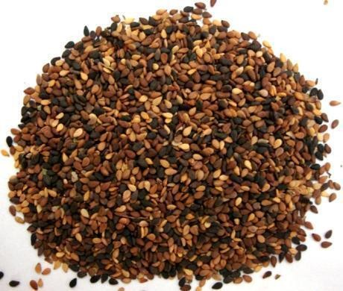
3 | Sesame light | Bag | 1,70 | 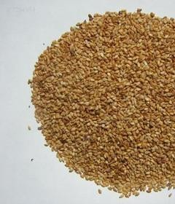

*Prices are shown on USD per kg.
** Prices are shown on FCA delivery terms – Republic of the Uzbekistan, According to Incoterms-2010.
*** Prices are valid until July 25, 2018.

